

**Housing Price Prediction**

Submitted by:

Matta Akhil Reddy

**ACKNOWLEDGMENT**

I would like to thank **FlipRobo Technologies** for providing me with this opportunity for writing the blog, and also in providing the guidance and constant support in providing necessary information regarding the project, by providing their support in completing the project

I also want to thank my **SME Ms.Khushboo garg** for their instant response in solving the problems and providing the valuable information by addressing out our query in right time.

**INTRODUCTION**

**Business Problem Framing:**

Houses are one of the necessary need of each and every person around the globe and therefore housing and real estate market is one of the markets which is one of the major contributors in the world’s economy.

It is a very large market and there are various companies working in the domain. Data science comes as a very important tool to solve problems in the domain to help the companies increase their overall revenue, profits, improving their marketing strategies and focusing on changing trends in house sales and purchases. Predictive modelling, Market mix modelling, recommendation systems are some of the machine learning techniques used for achieving the business goals for housing companies.

Our problem is related to one such housing company. A US-based housing company named **Surprise Housing** has decided to enter the Australian market. The company uses

data analytics to purchase houses at a price below their actual values and flip them at a higher price. For the same purpose, the company has collected a data set from the sale of houses in Australia.

The company is looking at prospective properties to buy houses to enter the market.

**Business Goal:**

You are required to model the price of houses with the available independent variables. This model will then be used by the management to understand how exactly the prices vary with the variables. They can accordingly manipulate the strategy of the firm and concentrate on areas that will yield high returns. Further, the model will be a good way for the management to understand the pricing dynamics of a new market.

We will have two types of data,

* Training Data - This data will contain the information related to the Year Sold and Sale Price of House.
* Test Data - It will contain all the information about a house. And, based on all the given information, Logistic Regression Algorithm will predict the selling price of a house.

**Conceptual Background of the Domain Problem**

Predictive modelling, Market mix modelling, recommendation systems

are some of the machine learning techniques used for achieving the

business goals for housing companies.

Hedonic Characteristics of Housing Price: A Hedonic approach is

preferred for predicting the sale prices in the housing market because

the market displays resilience, flexibility and spatial fixity.

Housing Attributes: Studying the structural, locational, and economic attributes of housing properties is crucial in understanding their mutually inclusive relationships with their pricing

**Motivation for the Problem Undertaken**

There is a steady rise in house demand with every passing year, and

consequently the house prices are rising every year. The problem

arises when there are numerous variables such as location and

property demand that influence the pricing. Therefore, buyers, sellers,

developers and the real estate industry are keen to know the most

important factors influencing the house price to help investors make

sound decisions and help house builders set the optimal house price.

There are many benefits that home buyers, property investors, and

house builders can reap from the house-price model. This model aims

to serve as a repository of such information and gainful insights to

home buyers, property investors and house builders, that will help

them determine best house prices.

This model can be useful for potential buyers in deciding the characteristics of a house they want that best fits their budget and will be of tremendous benefit, especially to housing developers and researchers, to ascertain the most significant attributes to determine house prices and to

acknowledge the best machine learning model to be used to conduct

a study in this field.

**Required Libraries**

Imported basic libraries in the basic level

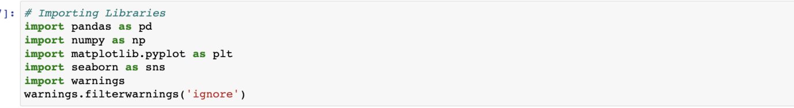

**Train Data & Test Data**

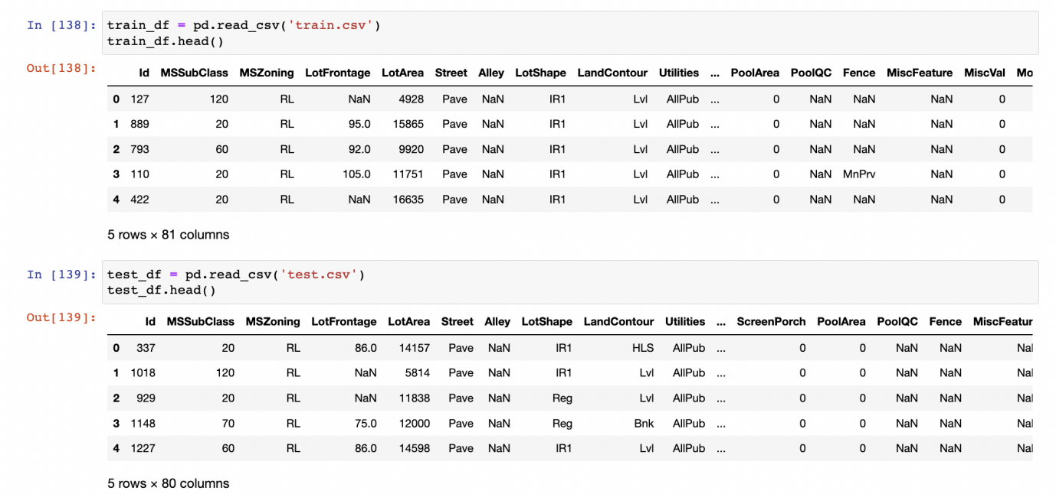

**Finding the shape of Train and test Data**

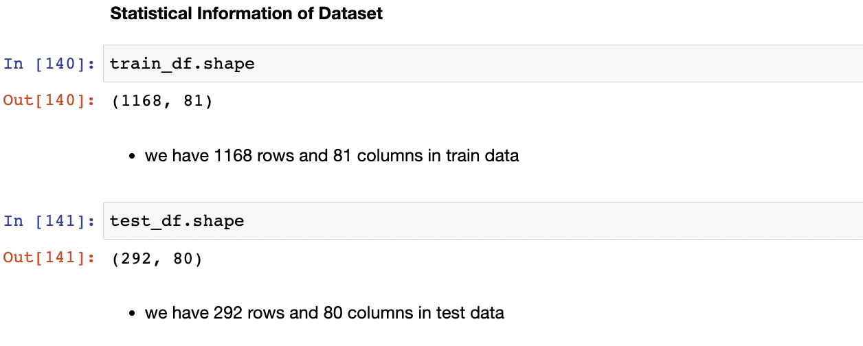

**Information of the Dataframe**

# Column Non-Null Count Dtype

--- ------ -------------- -----

0 Id 1168 non-null int64

1 MSSubClass 1168 non-null int64

2 MSZoning 1168 non-null object

3 LotFrontage 954 non-null float64

4 LotArea 1168 non-null int64

5 Street 1168 non-null object

6 Alley 77 non-null object

7 LotShape 1168 non-null object

8 LandContour 1168 non-null object

9 Utilities 1168 non-null object

10 LotConfig 1168 non-null object

11 LandSlope 1168 non-null object

12 Neighborhood 1168 non-null object

13 Condition1 1168 non-null object

14 Condition2 1168 non-null object

15 BldgType 1168 non-null object

16 HouseStyle 1168 non-null object

17 OverallQual 1168 non-null int64

18 OverallCond 1168 non-null int64

19 YearBuilt 1168 non-null int64

20 YearRemodAdd 1168 non-null int64

21 RoofStyle 1168 non-null object

22 RoofMatl 1168 non-null object

23 Exterior1st 1168 non-null object

24 Exterior2nd 1168 non-null object

25 MasVnrType 1161 non-null object

26 MasVnrArea 1161 non-null float64

27 ExterQual 1168 non-null object

28 ExterCond 1168 non-null object

29 Foundation 1168 non-null object

30 BsmtQual 1138 non-null object

31 BsmtCond 1138 non-null object

32 BsmtExposure 1137 non-null object

33 BsmtFinType1 1138 non-null object

34 BsmtFinSF1 1168 non-null int64

35 BsmtFinType2 1137 non-null object

36 BsmtFinSF2 1168 non-null int64

37 BsmtUnfSF 1168 non-null int64

38 TotalBsmtSF 1168 non-null int64

39 Heating 1168 non-null object

40 HeatingQC 1168 non-null object

41 CentralAir 1168 non-null object

42 Electrical 1168 non-null object

43 1stFlrSF 1168 non-null int64

44 2ndFlrSF 1168 non-null int64

45 LowQualFinSF 1168 non-null int64

46 GrLivArea 1168 non-null int64

47 BsmtFullBath 1168 non-null int64

48 BsmtHalfBath 1168 non-null int64

49 FullBath 1168 non-null int64

50 HalfBath 1168 non-null int64

51 BedroomAbvGr 1168 non-null int64

52 KitchenAbvGr 1168 non-null int64

53 KitchenQual 1168 non-null object

54 TotRmsAbvGrd 1168 non-null int64

55 Functional 1168 non-null object

56 Fireplaces 1168 non-null int64

57 FireplaceQu 617 non-null object

58 GarageType 1104 non-null object

59 GarageYrBlt 1104 non-null float64

60 GarageFinish 1104 non-null object

61 GarageCars 1168 non-null int64

62 GarageArea 1168 non-null int64

63 GarageQual 1104 non-null object

64 GarageCond 1104 non-null object

65 PavedDrive 1168 non-null object

66 WoodDeckSF 1168 non-null int64

67 OpenPorchSF 1168 non-null int64

68 EnclosedPorch 1168 non-null int64

69 3SsnPorch 1168 non-null int64

70 ScreenPorch 1168 non-null int64

71 PoolArea 1168 non-null int64

72 PoolQC 7 non-null object

73 Fence 237 non-null object

74 MiscFeature 44 non-null object

75 MiscVal 1168 non-null int64

76 MoSold 1168 non-null int64

77 YrSold 1168 non-null int64

78 SaleType 1168 non-null object

79 SaleCondition 1168 non-null object

80 SalePrice 1168 non-null int64

**Features Description**

* **Id** : Unique id of the housing prediction dataset
* **MSSubClass** : The Building class
* **MSZoning** : zone of the house(RL, RM, FV, RH, C(all))
* **LotFrontage** : Linear feet of street connected to property
* **LotArea** : Lot size in square feet
* **Street** : This talks about the type of road(Pave/gravel)
* **Alley** : Type of alley access (pave,grvl) note: we have nan values in this feature
* **LotShape** : general shape of the property('IR1', 'Reg', 'IR2', 'IR3')
* **LandContour** : Flatness of the property ['Lvl', 'Bnk', 'HLS', 'Low']
* **Utilities** : Type of utilities available['AllPub'], as we have only one variable we can drop
* **LotConfig** : Lot configuration ['Inside', 'CulDSac', 'FR2', 'Corner', 'FR3']
* **LandSlope** : Slope of property ['Gtl', 'Mod', 'Sev']
* **Neighborhood** : Physical locations within ames city limits ['NPkVill', 'NAmes', 'NoRidge', 'NWAmes', 'Gilbert', 'Sawyer','Edwards', 'IDOTRR', 'CollgCr', 'Mitchel', 'Crawfor', 'BrDale','StoneBr', 'BrkSide', 'NridgHt', 'OldTown', 'Somerst', 'Timber','SWISU', 'SawyerW', 'ClearCr', 'Veenker', 'Blmngtn', 'MeadowV','Blueste']
* **Condition1** : Proximity to main road or rail road ['Norm', 'Feedr', 'RRAn', 'PosA', 'RRAe', 'Artery', 'PosN', 'RRNe',
* 'RRNn']
* **Condition2** : Proximity to main road or rail road if a second is present ['Norm', 'RRAe', 'Feedr', 'PosN', 'Artery', 'RRNn', 'PosA', 'RRAn']
* **BldgType** : Type of dwelling ['TwnhsE', '1Fam', 'Duplex', 'Twnhs', '2fmCon']
* **HouseStyle** : style of dwelling ['1Story', '2Story', '1.5Fin', 'SFoyer', '1.5Unf', 'SLvl', '2.5Fin','2.5Unf']
* **OverallQual** : Overall quality [ 6, 8, 7, 5, 9, 1, 2, 4, 3, 10]
* **OverallCond** : Overall Condition [5, 6, 7, 4, 8, 2, 3, 9, 1]
* **YearBuilt** : Construction Date (min : 1875, max :2010)
* **YearRemodAdd** : remodel date (max:2010,min 1950)
* **RoofStyle** : Style of the roof ['Gable', 'Flat', 'Hip', 'Shed', 'Gambrel', 'Mansard']
* **RoofMatl** : roof material ['CompShg', 'Tar&Grv', 'WdShngl', 'WdShake', 'Roll', 'ClyTile','Metal', 'Membran']
* **Exterior1st** : Exterior covering of house ['Plywood', 'Wd Sdng', 'MetalSd', 'CemntBd', 'VinylSd', 'HdBoard','Stucco', 'WdShing', 'BrkFace', 'Stone', 'AsbShng', 'AsphShn','ImStucc', 'BrkComm']
* **Exterior2nd** : Exterior covering of house if more than one material ['Plywood', 'Wd Sdng', 'MetalSd', 'CmentBd', 'VinylSd', 'HdBoard','Wd Shng', 'Stucco', 'ImStucc', 'Stone', 'BrkFace', 'AsbShng','Brk Cmn', 'AsphShn', 'Other']
* **MasVnrType** : Masonry veneer type ['None', 'BrkFace', 'Stone', 'BrkCmn', nan] we have nan and None type values here
* **MasVnrArea** : Masonry veneer area in square feet
* **ExterQual** : Exterior material quality ['TA', 'Gd', 'Ex', 'Fa']
* **ExterCond** : present condition of the material on the exterior ['TA', 'Gd', 'Fa', 'Po', 'Ex']
* **Foundation** : Type of foundation ['CBlock', 'PConc', 'BrkTil', 'Slab', 'Stone', 'Wood']
* **BsmtQual** : Height of the basement ['Gd', 'TA', 'Ex', nan, 'Fa'] we have NaN values
* **BsmtCond** : General condition of the basement ['TA', 'Gd', 'Fa', nan, 'Po'] we have NaN values
* **BsmtExposure** : walk out or garden level basement walls ['No', 'Gd', 'Av', 'Mn', nan] we have Nan values
* **BsmtFinType1** : quality of basement finished area ['ALQ', 'GLQ', 'BLQ', 'Unf', 'Rec', 'LwQ', nan]
* **BsmtFinSF1** : type 1 finished square feet.
* **BsmtFinType2** : quality of seconf finished area if present ['Unf', 'Rec', 'BLQ', 'GLQ', nan, 'ALQ', 'LwQ'] we have nan values
* **BsmtFinSF2** : Type 2 finished square feet
* **BsmtUnfSF** : Unfinished squarefeet of basement area
* **TotalBsmtSF** : Total sqaure feet of basement area
* **Heating** : type of heating ['GasA', 'GasW', 'Floor', 'OthW', 'Wall', 'Grav']
* **HeatingQC** : Heating quality and condition ['TA', 'Ex', 'Gd', 'Fa', 'Po']
* **CentralAir** : Central Air condition
* **Electrical** : electrical system ['SBrkr', 'FuseA', 'FuseF', 'FuseP', 'Mix']
* **1stFlrSF** : first floor square feet
* **2ndFlrSF** : second floor square feet
* **LowQualFinSF** : low quality finished square feet all floors
* **GrLivArea** : above grade living area square feet
* **BsmtFullBath** : basement full bathrooms
* **BsmtHalfBath** : basement half bathrooms
* **FullBath** : full bath rooms above grade
* **HalfBath** : Half baths above grade
* **BedroomAbvGr** : no of bedrroms above basement level
* **KitchenAbvGr** : no of kitchens
* **KitchenQual** : Kitchen quality
* **TotRmsAbvGrd**: Total rooms above grade (does not include bathrooms)
* **Functional**: Home functionality rating
* **Fireplaces**: Number of fireplaces
* **FireplaceQu**: Fireplace quality
* **GarageType**: Garage location
* **GarageYrBlt**: Year garage was built
* **GarageFinish**: Interior finish of the garage
* **GarageCars**: Size of garage in car capacity
* **GarageArea**: Size of garage in square feet
* **GarageQual**: Garage quality
* **GarageCond**: Garage condition
* **PavedDrive**: Paved driveway
* **WoodDeckSF**: Wood deck area in square feet
* **OpenPorchSF**: Open porch area in square feet
* **EnclosedPorch**: Enclosed porch area in square feet
* **3SsnPorch**: Three season porch area in square feet
* **ScreenPorch**: Screen porch area in square feet
* **PoolArea**: Pool area in square feet
* **PoolQC**: Pool quality
* **Fence**: Fence quality
* **MiscFeature**: Miscellaneous feature not covered in other categories
* **MiscVal**: Value of miscellaneous feature
* **MoSold**: Month Sold
* **YrSold**: Year Sold
* **SaleType**: Type of sale
* **SaleCondition**: Condition of sale

**Data Preprocessing**

**Checking For the Null Values in the Dataset**

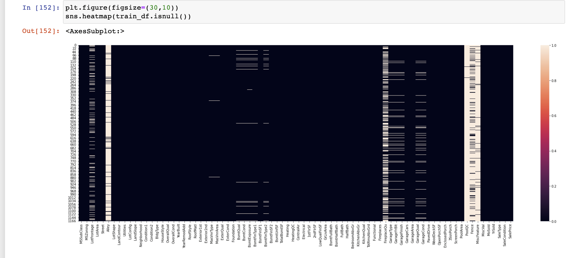

**we have Null values in**

* LotFrontage
* Alley
* MasVnrType
* MasVnrArea
* BsmtQual
* BsmtCond
* BsmtExposure
* BsmtFinType1
* BsmtFinType2
* FireplaceQu
* GarageType
* GarageYrBlt
* GarageFinish
* GarageQual
* GarageCond
* PoolQC
* Fence
* MiscFeature

The ID columns from test and train datasets were dropped

since they don't contribute to building a good model for predicting

the target variable values

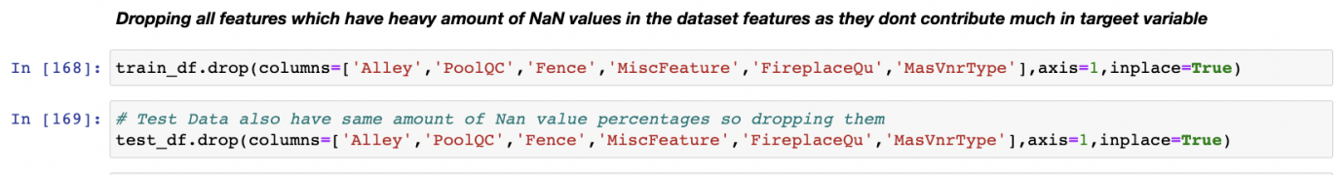

**Data Inputs- Logic- Output Relationships**

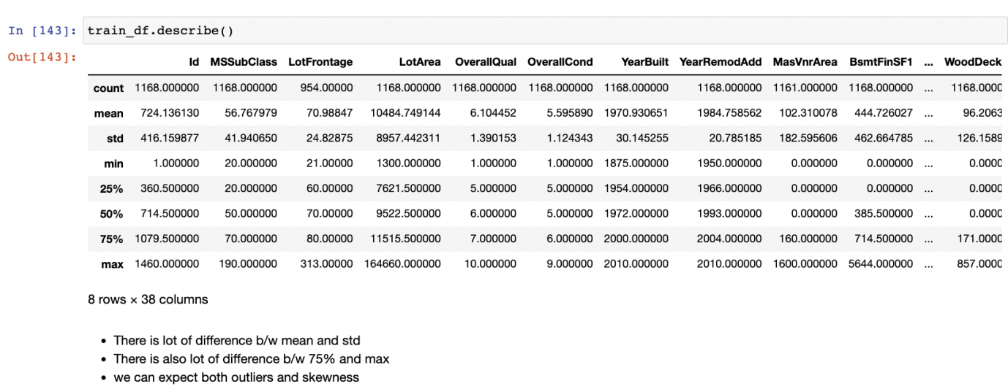

Based on the above results i have observed.

* Huge Difference b/w max value and 75% in SalePrice, MSSubClass, LotFrontage,LotArea, BsmtFinSF1,BsmtFinSF2 etc which are indicating presence of outliers.
* There is the presence of higher standard deviation which indicates the presence of skewness.

**Hardware and Software Requirements and Tools Used**

**Hardware Used:**

* Processor Apple M1
* Physical Memory: 8 GB

**Softwares Used:**

* MAC Operating System
* Anaconda Package and Environment Manager: Anaconda is a distribution of the Python and R programming languages for scientific computing, that aims to simplify package management and deployment. The distribution includes datascience packages suitable for Windows and provides a host of tools and environment for conducting Data Analytical and Scientific works. Anaconda provides all the necessary Python packages and libraries for Machine learning projects.
* Jupyter Notebook: The Jupyter Notebook is an open-source web application that allows data scientists to create and share documents that integrate live code, equations, computational output, visualizations, and other multimedia resources, along with explanatory text in a single document.
* Python3: It is open source, interpreted, high level language and provides great approach for object-oriented programming. It is one of the best languages used for Data Analytics And Data science projects/application. Python provides numerous libraries to deal with mathematics, statistics and scientific function.
* Python Libraries
* Pandas: For carrying out Data Analysis, Data Manipulation, Data Cleaning etc
* Numpy: For performing a variety of operations on the datasets.
* matplotlib.pyplot, Seaborn: For visualizing Data and various relationships between Feature and Label Columns
* Scipy: For performing operations on the datasets
* Statsmodels: For performing statistical analysis
* sklearn for Modelling Machine learning algorithms, Data Encoding, Evaluation metrics, Data Transformation,Data Scaling, Component analysis,Feature selection etc

**Visualisation For Object Type Features**

**Univariate Analaysis**

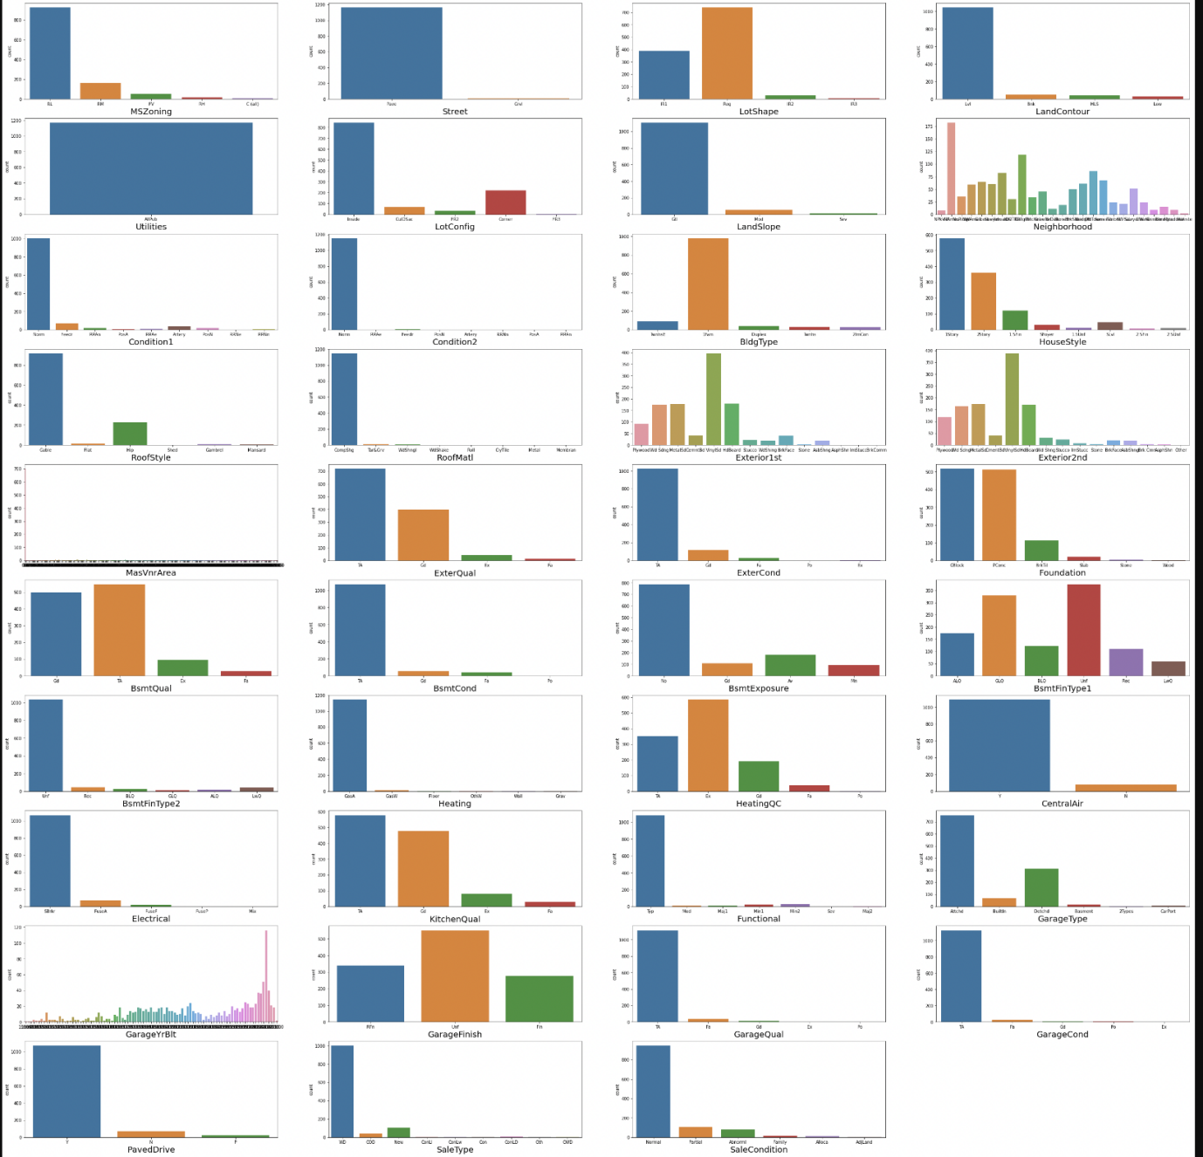

**Observations**

* MSZoning has the more data related to RL
* Most common street type isi pave
* Most of the Lotshapes has the regular structures
* Most of the properties has lv1
* utilities has only one value(ALLPUB)
* Most common LotConfig is Inside type
* slope of property land is mostly gentle
* Most of the properties are situated in neighborhoods of Neighborhoods of North AMerica,followed by college creek Edwards and old town
* Most of the housing properties with feature condition1 and condition2 are in normal conditions
* Mostly all the propertie sare 1 storey and 2 storey
* Most of the properties with feature BldgtYPE HAS IFam type
* Most of properties have the Gable type roofstyle
* Most of the properties used roofMatl has Compshg
* most of the properties has Exteriors has vinylsd type
* most of properties dont have masonry veneer type while some has brick face
* Most of the properties has the typical/average exteriors
* Most of the properties has the typical/average exterior conditions
* most of the properties has foundation type as cblock.pconc
* The height of the basement is usually either typical (80-89 inches) or good (90-99 inches)
* The general condition of the basement is commonly Typical with slight dampness
* Basements most commonly have no exposure
* Most of the houses basements are unfinished followed by houses with basements having good living quarters
* most houses have gas forced warm air furnance heating arrangment
* most properties have good good quality and condition
* most properties have air conditioning
* most properties have standarad circuit breakers and romex electrical system
* most properties have good kitchen quality
* most properties has garage attached to home
* most of the properties has unfinished garage
* garage condition is usually typical/average
* conventional is most common type of sale

**Bivariate Analaysis**

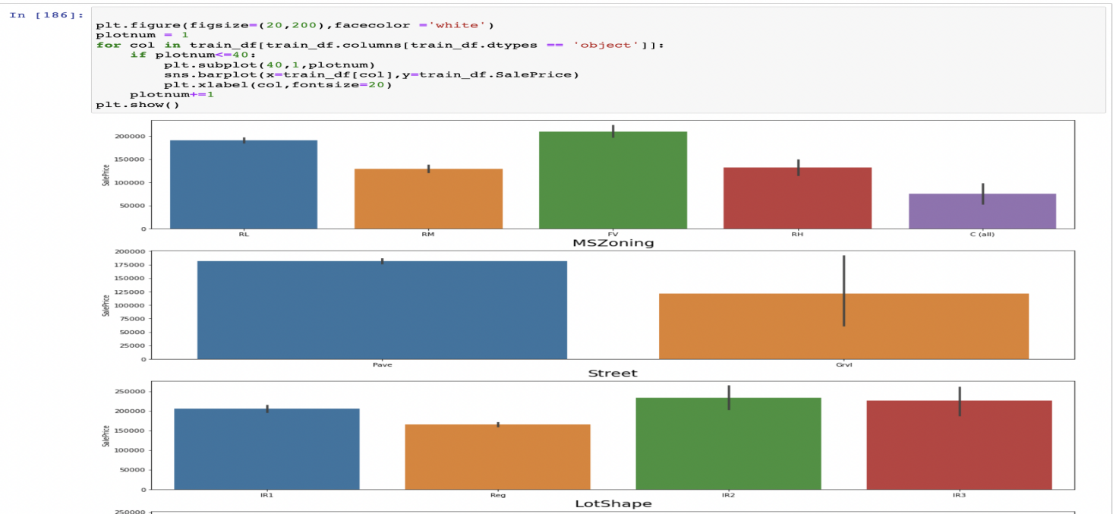

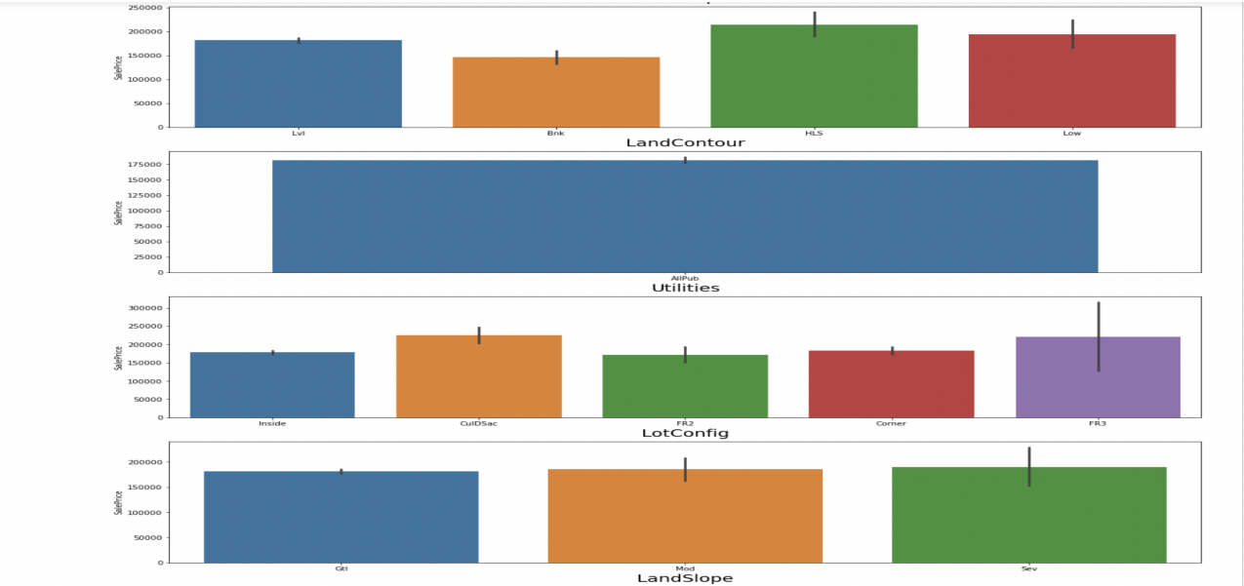

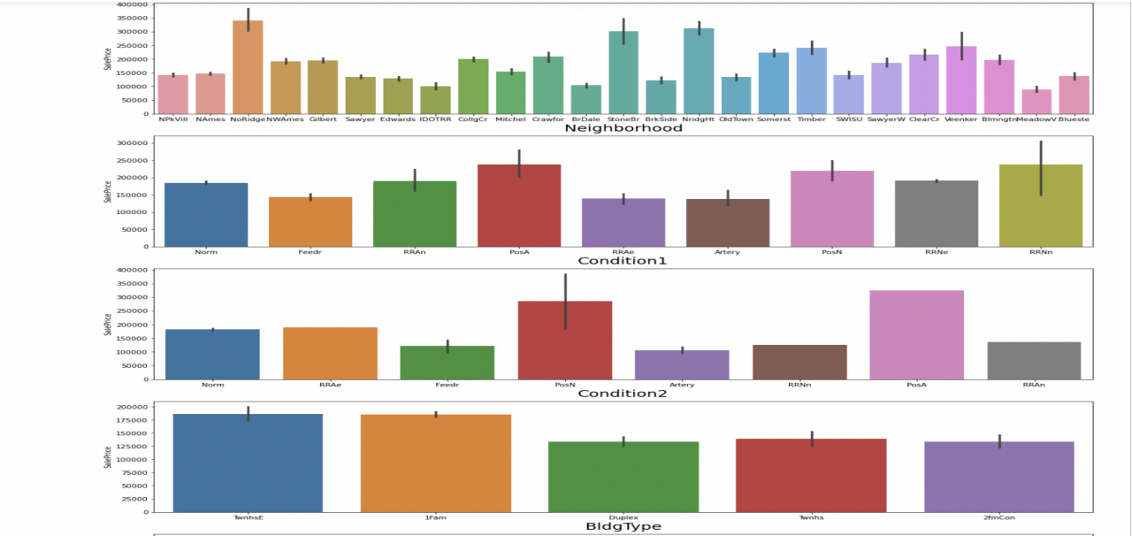

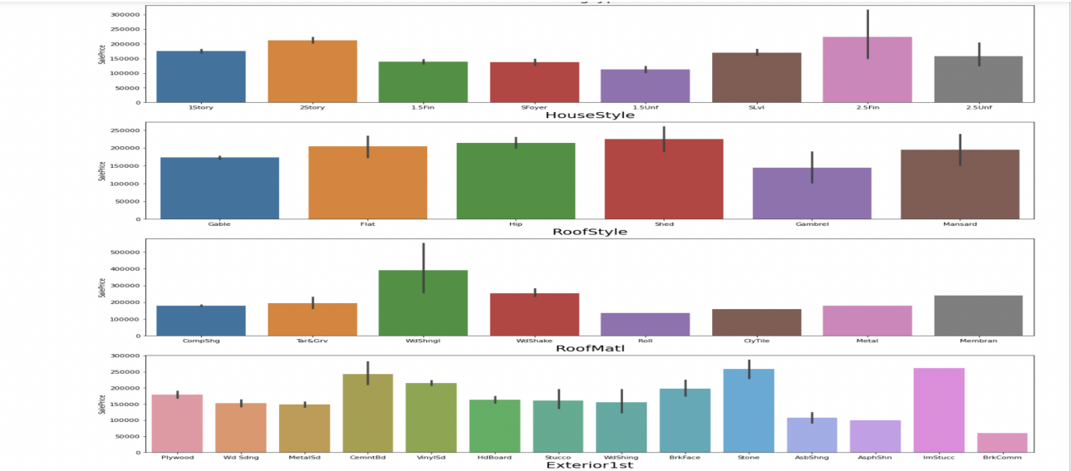

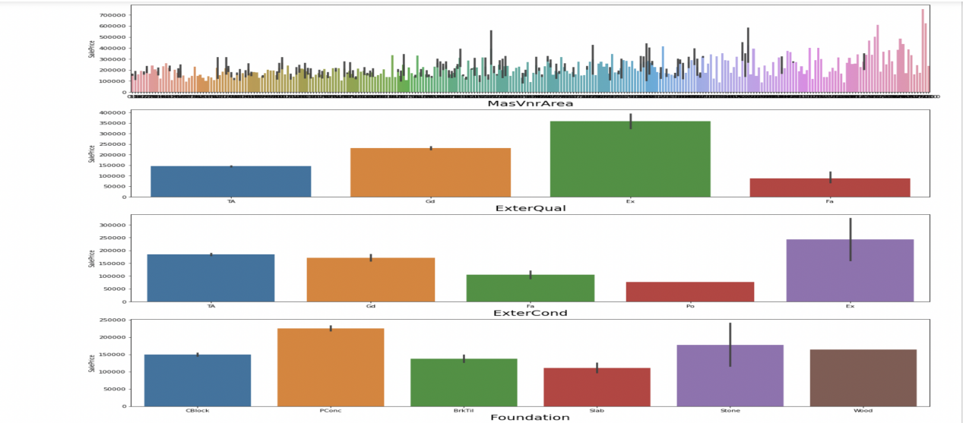

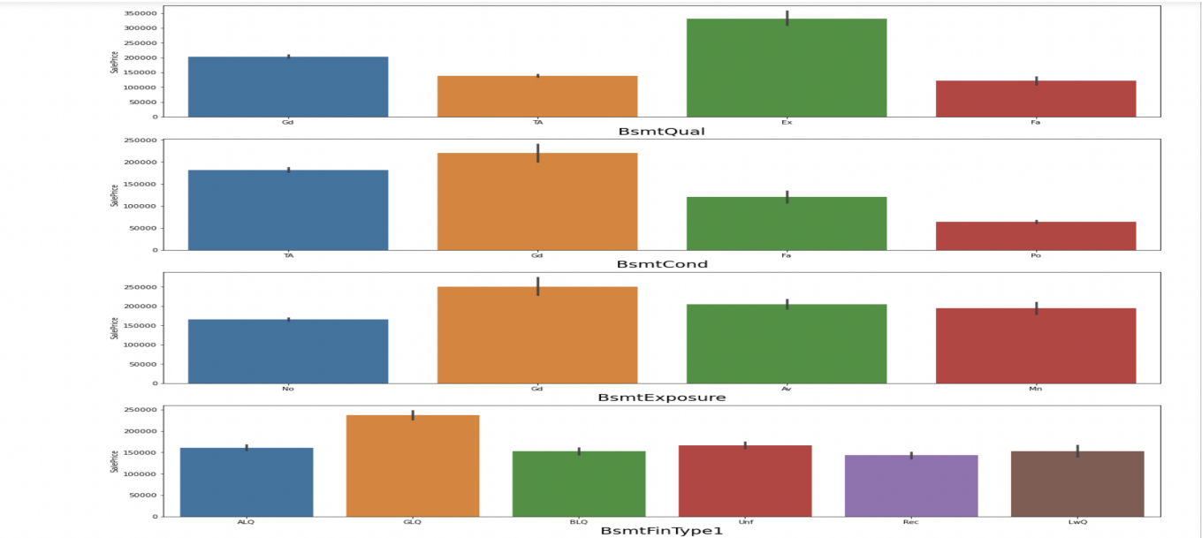

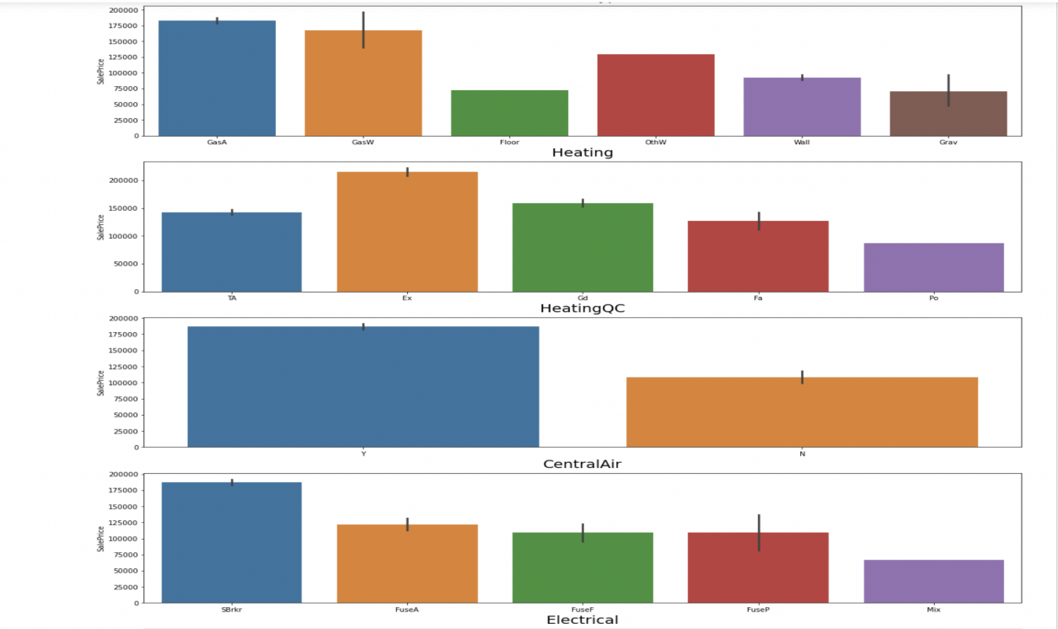

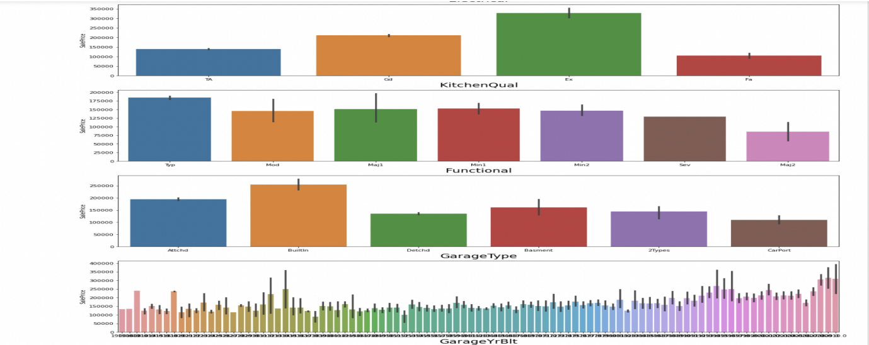

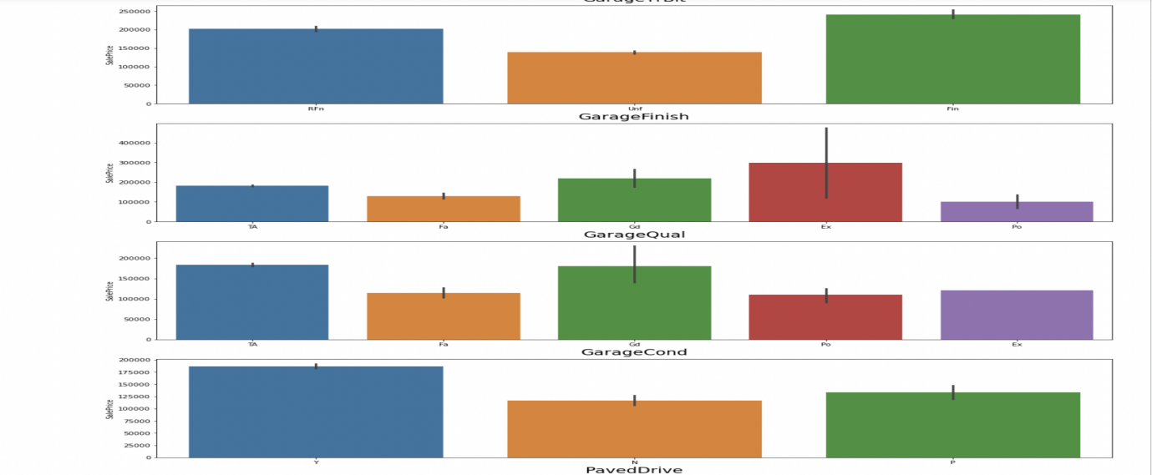

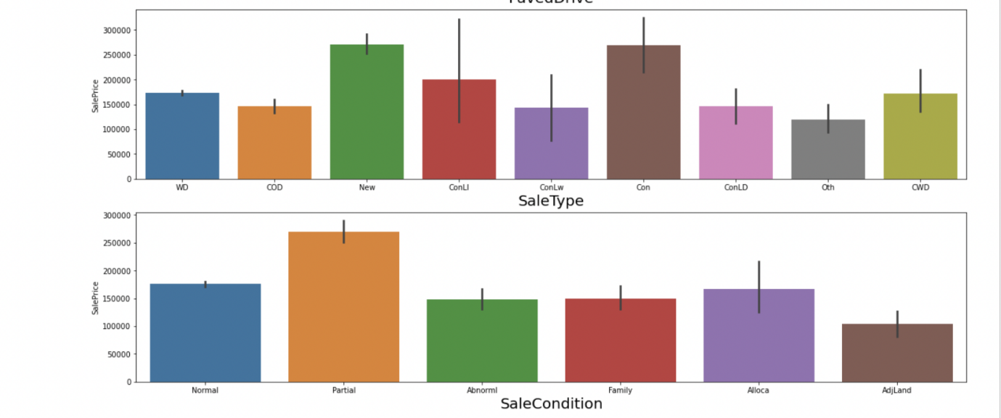

**Observations:**

* In MSZoning most of the sale price is contributed by FV
* Most of streetw which are contributed in high sale price is Pvae type streets
* High sale price is also contributed by having the LotShape of the house as IR2 followed by IR3 and IR1
* High sale price is contributed bu having LandContour as HLS followed by Low and Lvl type
* LotConfig feature has high sale price when the config type is either FR3 or CulDSac
* Landslope feature is contributing equally in sale price
* Neighbourhood feature of saleprice is highly contributing with variable NoRidge
* In Condition1 and Condition2 feature the sale price is high when the variable is POSA followed by PosN
* BldgType feature with variable TwnhsE,1Fam contributing more for the saleprice
* HouseStyle with 2.5Fin, 2Story are contrbuting more in house sale price
* Roofstyle with Shed type followed by Hip,Flat, Mansard are contributing more for the saleprice
* The house with RoofMatl WidShngl is contributing the high cost in the saleprice
* Exterior1st feature with Stone,CemntBd type are contributing more for the house sale price
* Exterior2nd feature with Other,ImStucc type are contributing more for the house sale price
* ExterQual feature with Ex type is contributing more for the saleprice
* ExterCond feature with Ex type is contributing more for the saleprice and variable Po is contributing less with saleprice
* Foundation feature with Pconc is contributing more with the saleprice
* BsmtQual with ex type has the high sale price
* BsmtCond with Gd TYPE HAS THE high sale price
* BsmtExposure with Gd type has the high sale price
* BsmtFinType1 feature with GLQ has the high sale price
* BsmtFinType1 feature with GLQ,ALQ has the high sale price
* Heating Feature with GasA type is having teh high sale price
* HeatingQC feature with Ex type is contributing more for saleprice
* High sale price for houses will happen when there is central air conditioning system
* KitchenQual with Ex type is contributing more for the sale price
* Functional feature with Typ type is contributing more for sale price
* Builtin Garage type is having high saleprice whereas Detchd type has less contribution for sale price
* GarageFinish with Fin type has high contribution towards saleprice
* GarageQual with Gd type has high saleprice
* GarageCond with Gd type is contributing more for saleprice
* Yes paved drive is contributing more for sale price
* saletype with New,Con type has high saleprices
* Partial condition is having high sale price

**Visualisation For Numerical Type Features**

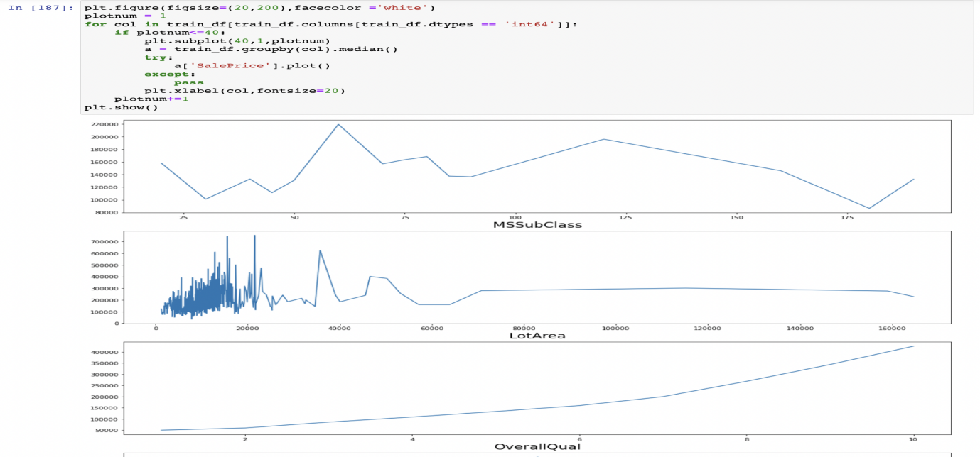

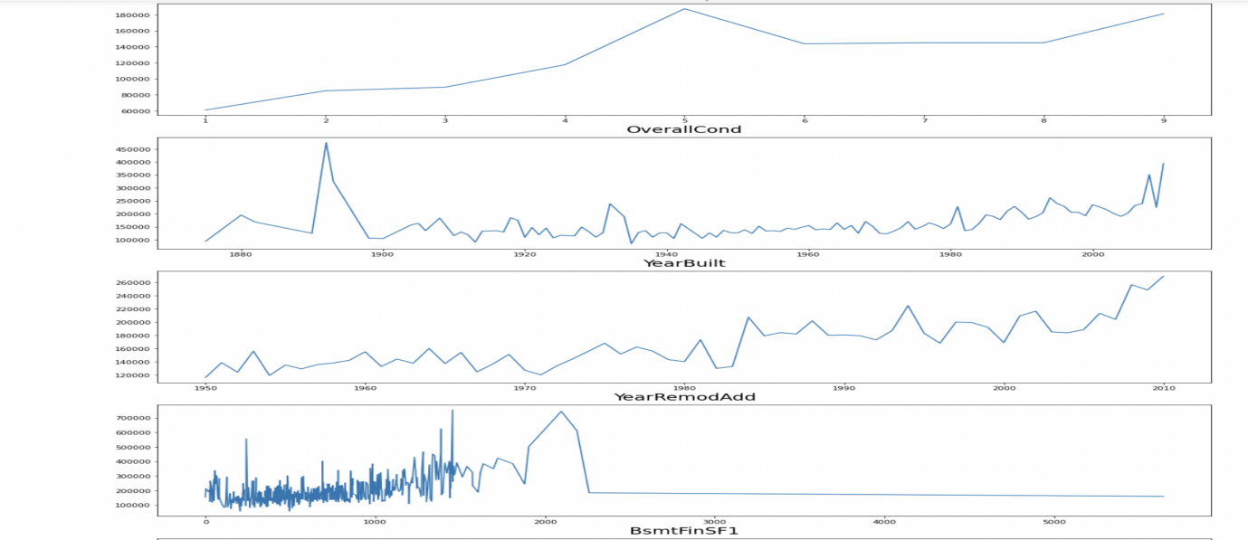

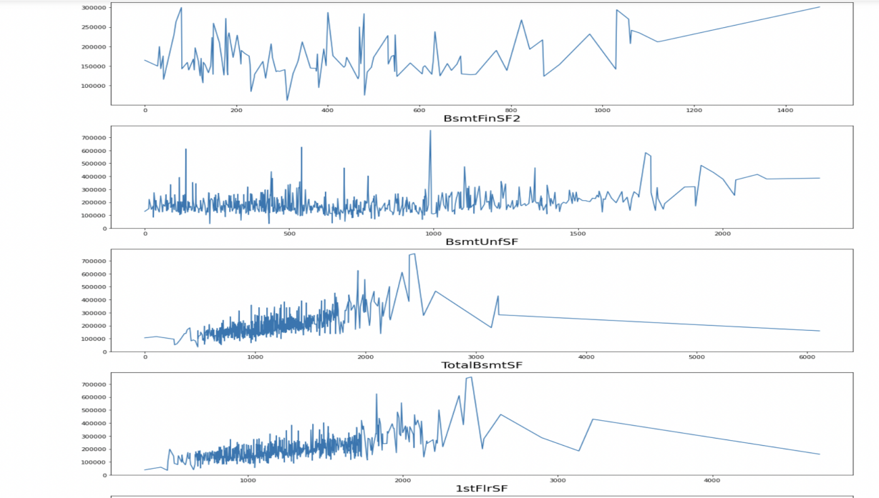

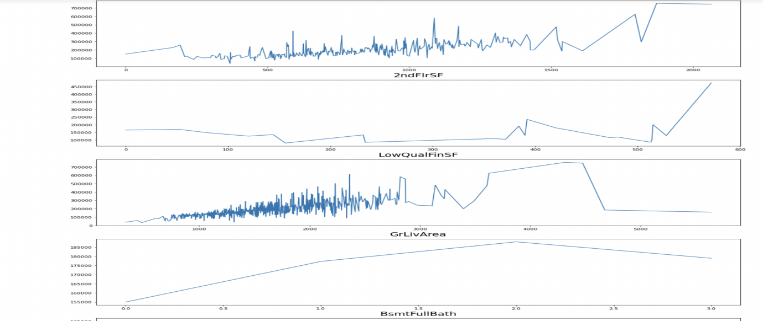

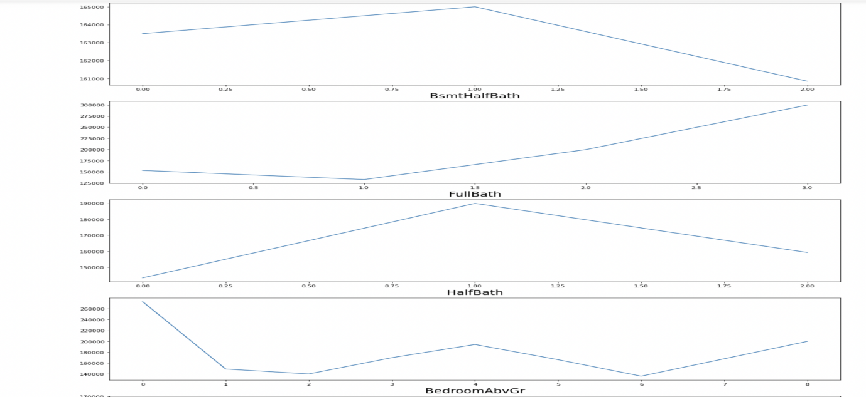

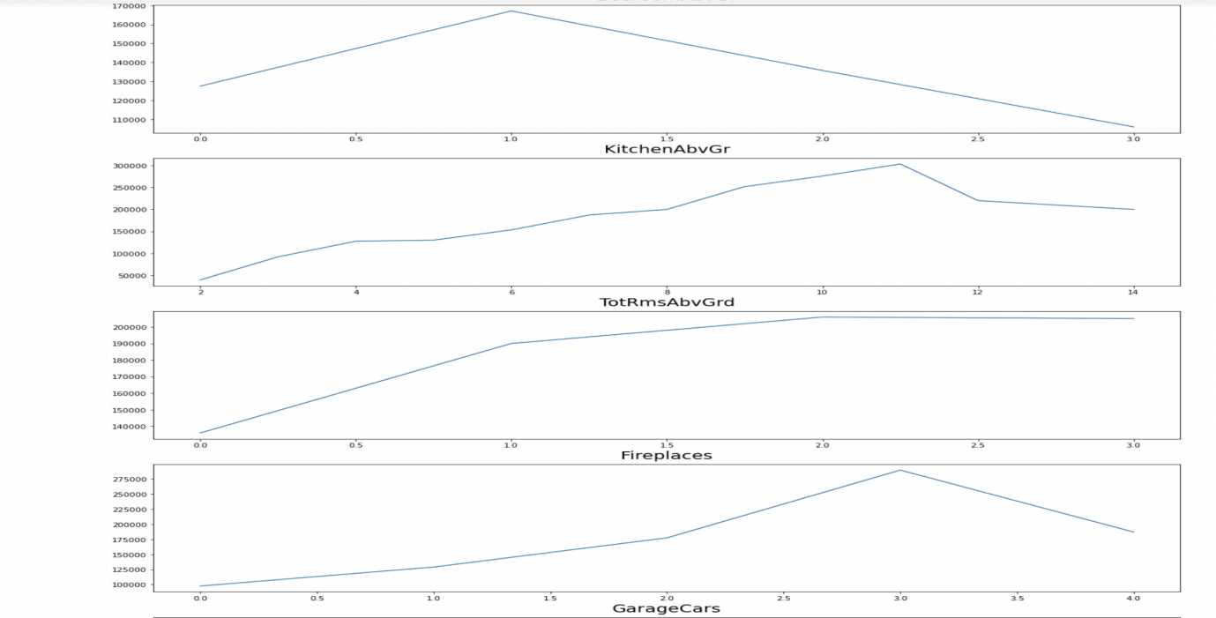

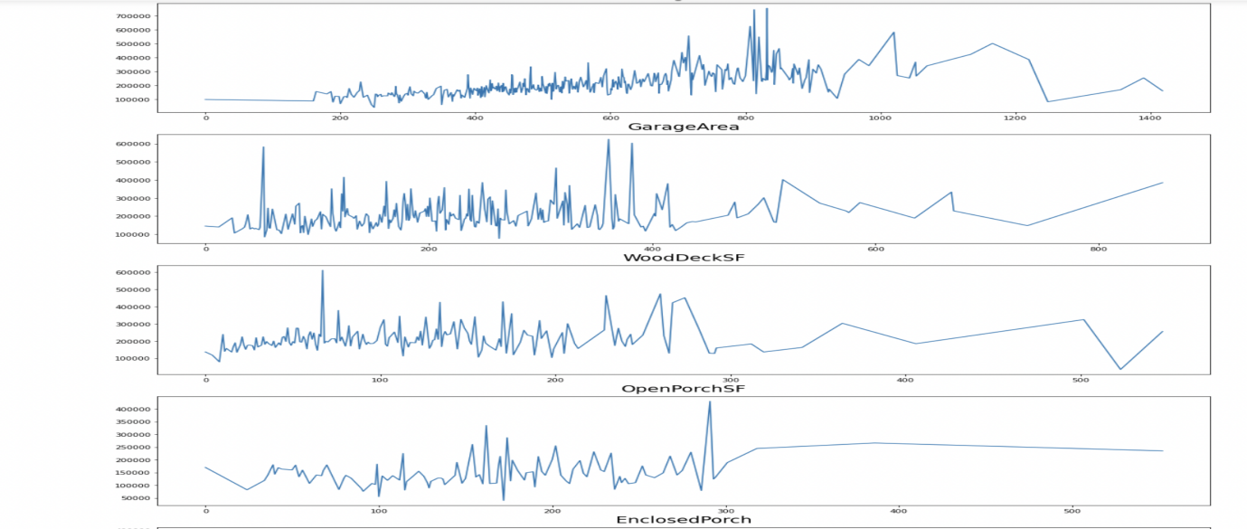

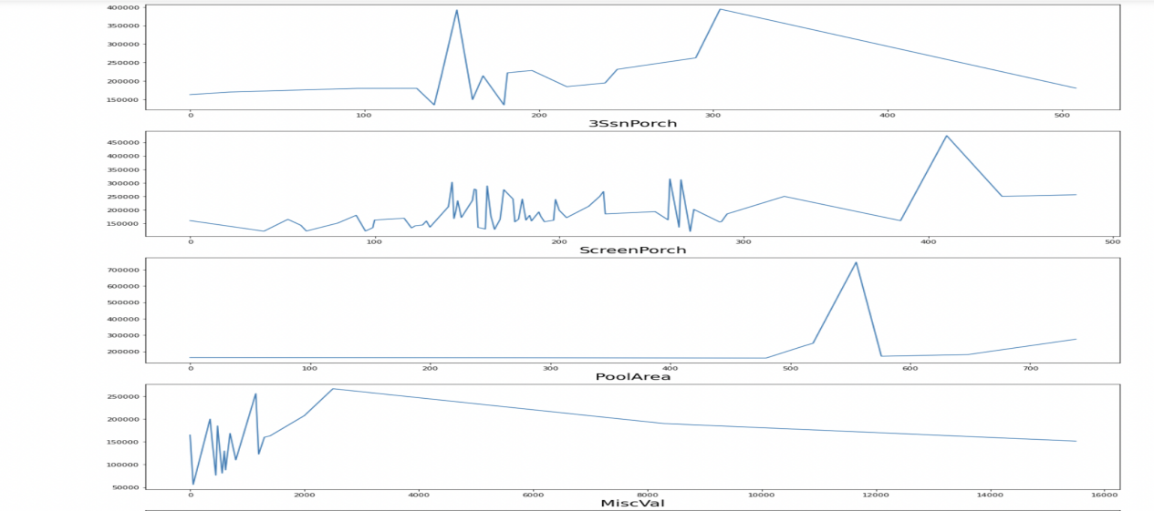

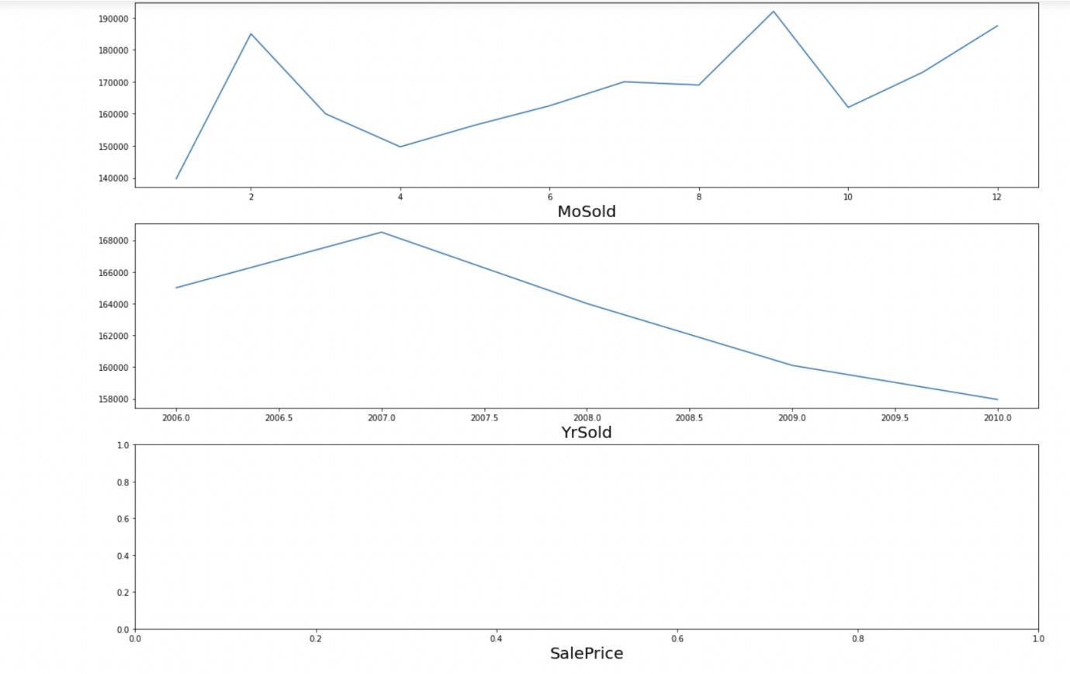

**Observations:**

* 1 story and 2 and 2.5 story houses built in 1946 and newer fetch the highest amount in sales.
* Houses with LotFrontage between 100 ft and 200 ft are sold for the highest amount.
* Houses wtih Lot area upto 25000 sqft fetch the highest amount.
* There is a Linear positive relation between Overall Quality and SalesPriceo There is a Linear positive relation between Overall Condition and SalesPrice
* There is a Linear positive relation between Masonry veneer area and SalesPrice
* Most Sales were done for Type 1 Finished basement with area upto 2500 sqft
* There is a Linear positive relation between Type 2 Finished basement area and SalesPrice
* There is a Linear positive relation between Total Basement area and SalesPrice
* There is a Linear positive relation between Total 1st area and 2nd floor area and SalesPrice
* There is a Linear positive relation between low Quality finished square feet and SalesPrice
* There is a Linear positive relation between Above grade living area square feet and SalesPrice
* There is a Linear negative relation between basment half bath and SalesPrice
* There is a Linear positive relation between Full Bathroom and SalesPrice
* There is a Linear positive relation between Total rooms above grade and SalesPrice
* There is a Linear positive relation between Fireplaces and SalesPrice
* There is a Linear positive relation between Garage Car capacity and SalesPrice
* There is a Linear positive relation between Garage area and SalesPrice
* Sales Prices peaked between 0-400 square feet area for Wooden Deck
* Sales Prices peaked between 0-300 square feet area for Open Porch
* Sales Price and Enclosed Porch area have a positive relation
* Sales Price and 3 season Porch area have a positive relation
* Sales Price and screen Porch area have a positive relation
* Sales Price and Month Sold have a positive relation
* Sales Price and Month Sold have a positive relation
* Sales Price and house age have a negative relationo Sales Price and remodelling age have a negative relation
* Sales Price and Garage age have a negative relation.

**As we have some of the date related variables is some features in string format modifying it into Datetime format and extract useful insights from it.**

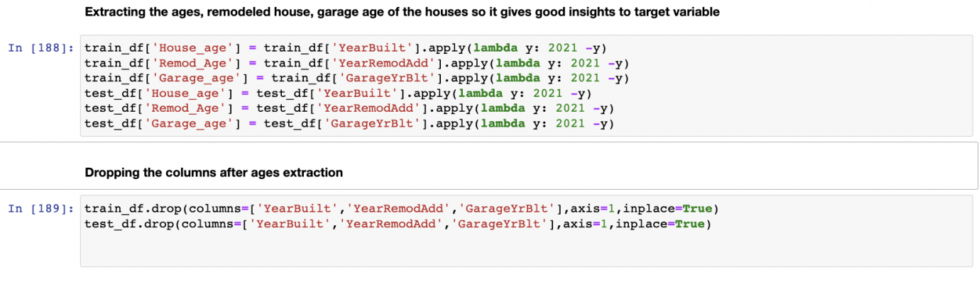

**As we have some object related data(Categeorical), to create a Ml model we need all the data in Numerical format so Label encoding the values.**

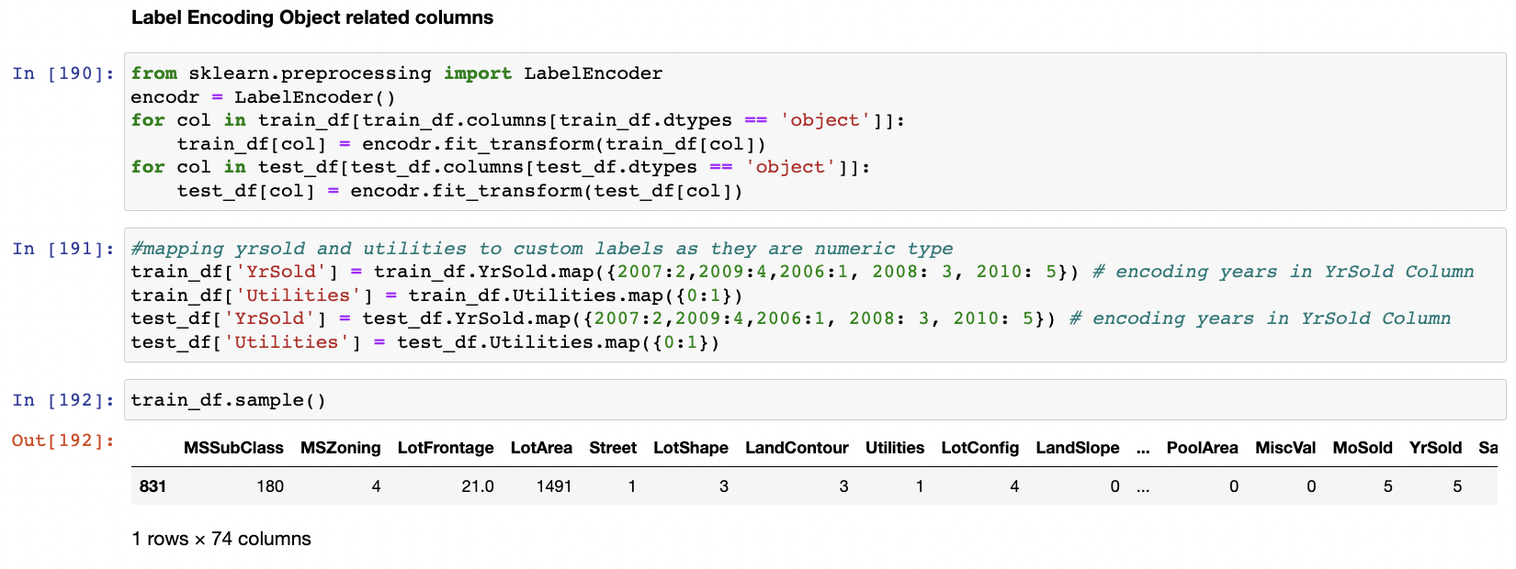

**Checking For Outliers in the Dataset**

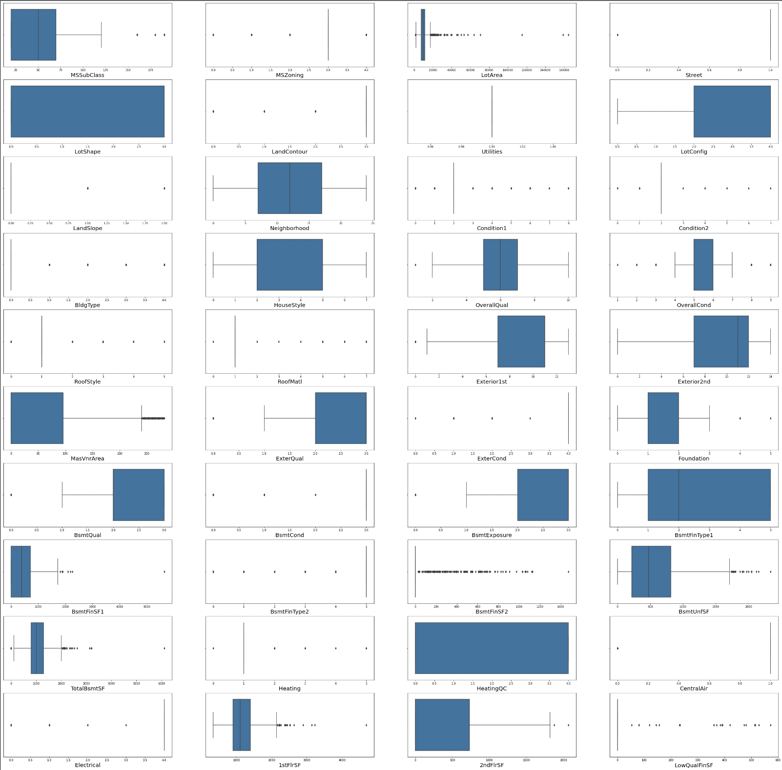

We have some outliers in the dataset.

**Lets Check the Amount of outliers present in Dataset Using Z-score method**

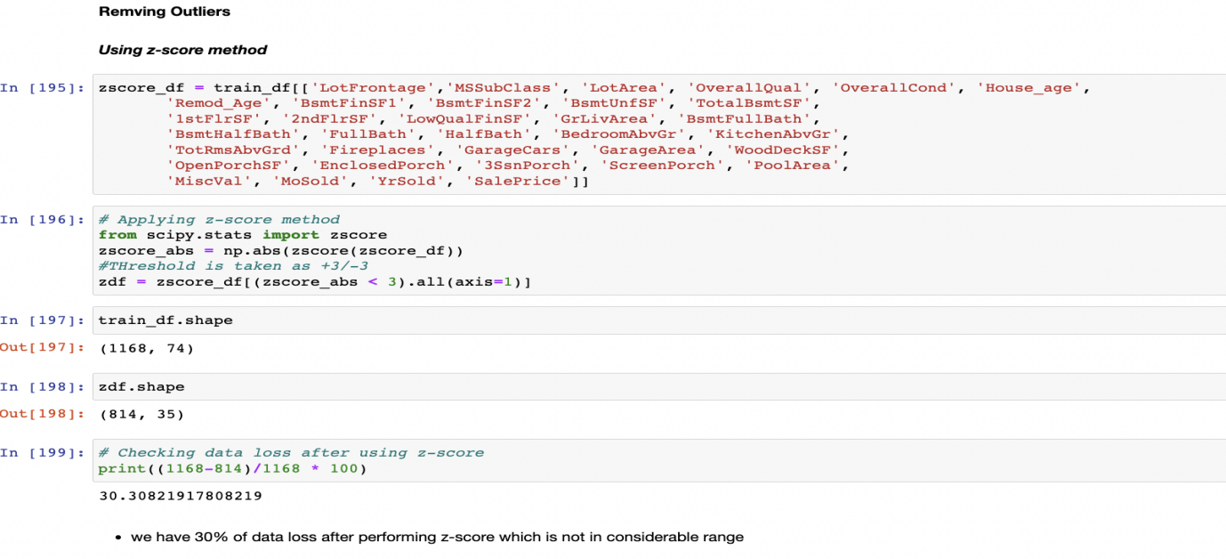

After Removing the outliers using z-score we have data loss of 30% which is not in considerable range

**Lets Check the Amount of outliers present in Dataset Using IQR method**

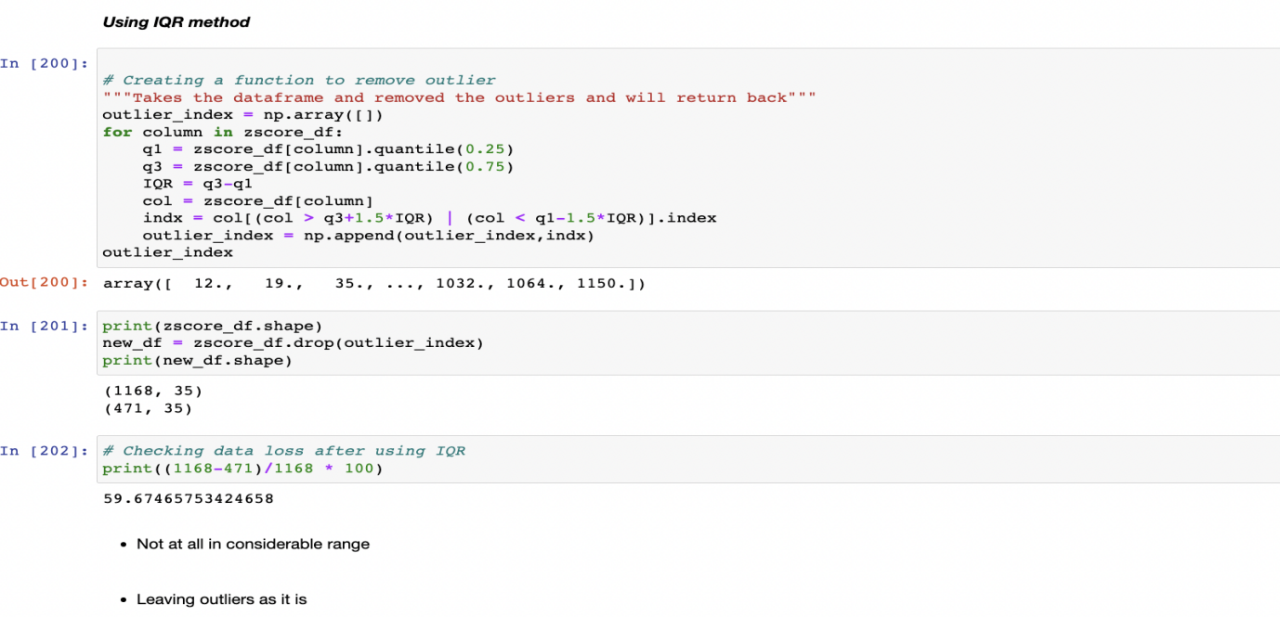

After Removing the outliers using IQR we have data loss of 59% which is not in considerable range

**So leaving the outliers as it is because i dont want to lose the valuable data.**

**Checking for the skewness in the Dataset**

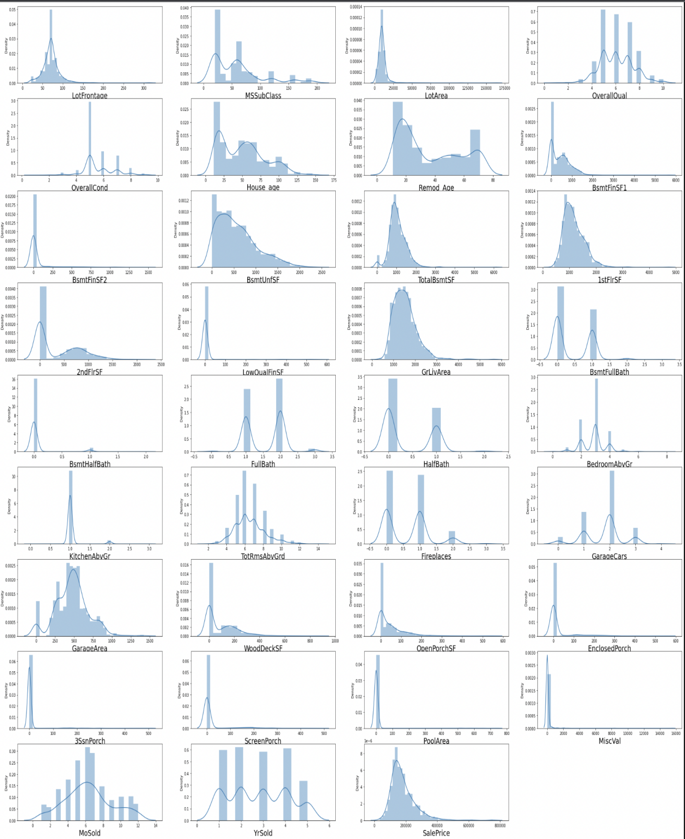

Lot of the data are right skewed in the dataframe

Some of the columns are multinodal.

**Skewness Values**

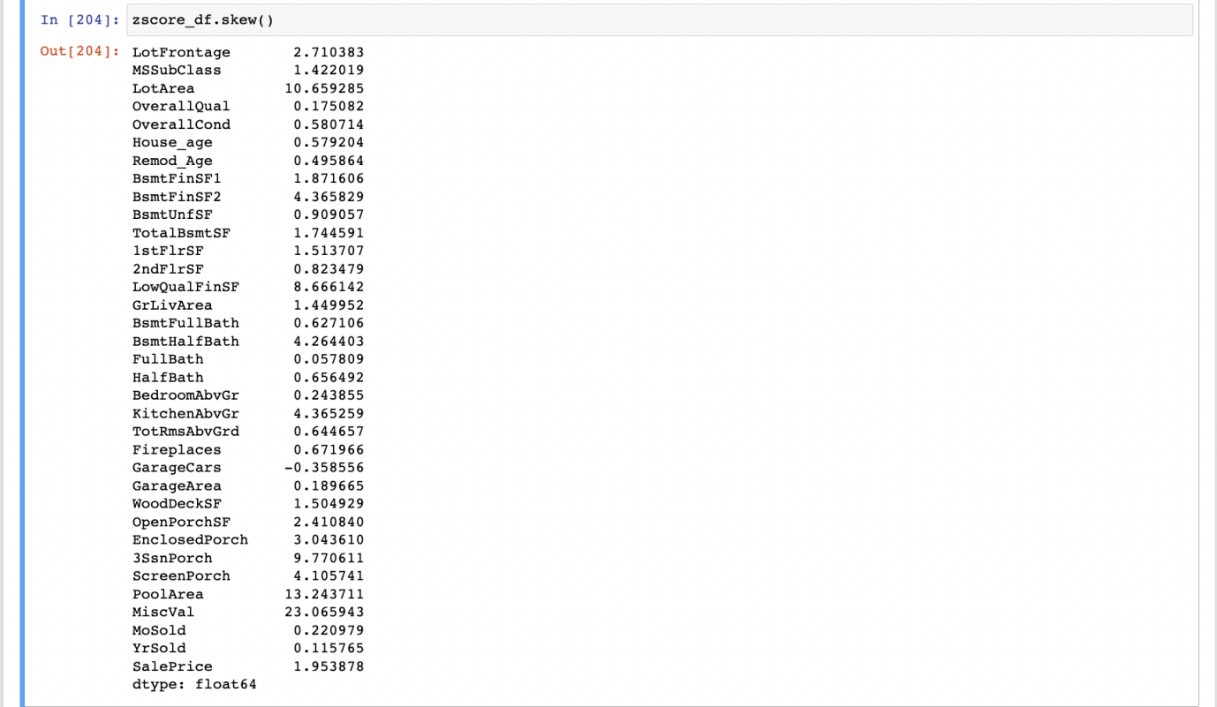

**Handling Skewness Using PowerTransformer**

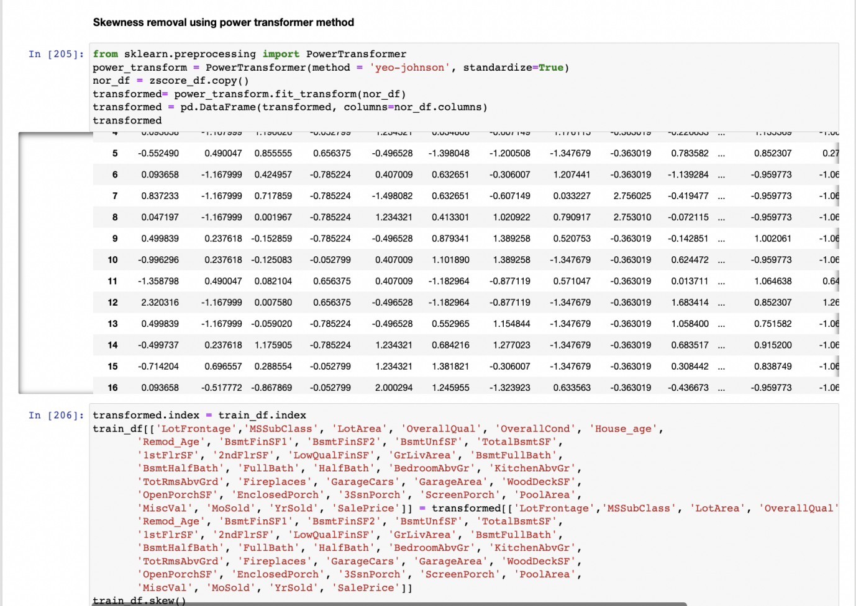

**After handling the skewness the values are:**

MSSubClass 0.064007

MSZoning -1.796785

LotFrontage 0.161368

LotArea 0.032509

Street -17.021969

LotShape -0.603775

LandContour -3.125982

Utilities 0.000000

LotConfig -1.118821

LandSlope 4.812568

Neighborhood 0.043735

Condition1 3.008289

Condition2 11.514458

BldgType 2.318657

HouseStyle 0.285680

OverallQual 0.021658

OverallCond 0.048063

RoofStyle 1.498560

RoofMatl 7.577352

Exterior1st -0.612816

Exterior2nd -0.592349

MasVnrArea 1.355502

ExterQual -1.810843

ExterCond -2.516219

Foundation -0.002761

BsmtQual -1.343781

BsmtCond -3.293554

BsmtExposure -1.166987

BsmtFinType1 -0.068901

BsmtFinSF1 -0.404528

BsmtFinType2 -3.615783

BsmtFinSF2 2.394737

BsmtUnfSF -0.284390

TotalBsmtSF 0.286779

Heating 10.103609

HeatingQC 0.449933

CentralAir -3.475188

Electrical -3.104209

1stFlrSF -0.002391

2ndFlrSF 0.280208

LowQualFinSF 6.922843

GrLivArea -0.000054

BsmtFullBath 0.365488

BsmtHalfBath 3.954345

FullBath -0.045944

HalfBath 0.498003

BedroomAbvGr 0.116498

KitchenAbvGr -2.370593

KitchenQual -1.408106

TotRmsAbvGrd 0.002332

Functional -3.999663

Fireplaces 0.084950

GarageType 0.831142

GarageFinish -0.450190

GarageCars -0.022970

GarageArea -0.320370

GarageQual -4.582386

GarageCond -5.422472

PavedDrive -3.274035

WoodDeckSF 0.113026

OpenPorchSF -0.002749

EnclosedPorch 2.022616

3SsnPorch 7.087955

ScreenPorch 3.067153

PoolArea 12.817372

MiscVal 4.991071

MoSold -0.035838

YrSold -0.083577

SaleType -3.660513

SaleCondition -2.671829

SalePrice -0.006010

House_age -0.063679

Remod_Age 0.039294

Garage_age 0.708074

most of the skewness is removed from the data

**Handled the same for test data also:**

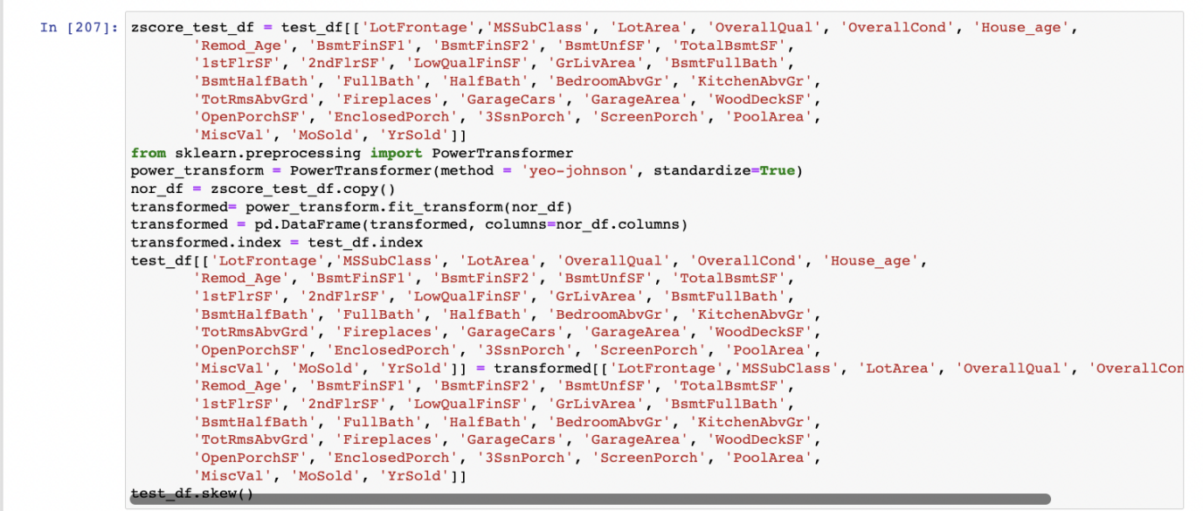

**Analayzing Correlation in train Data**

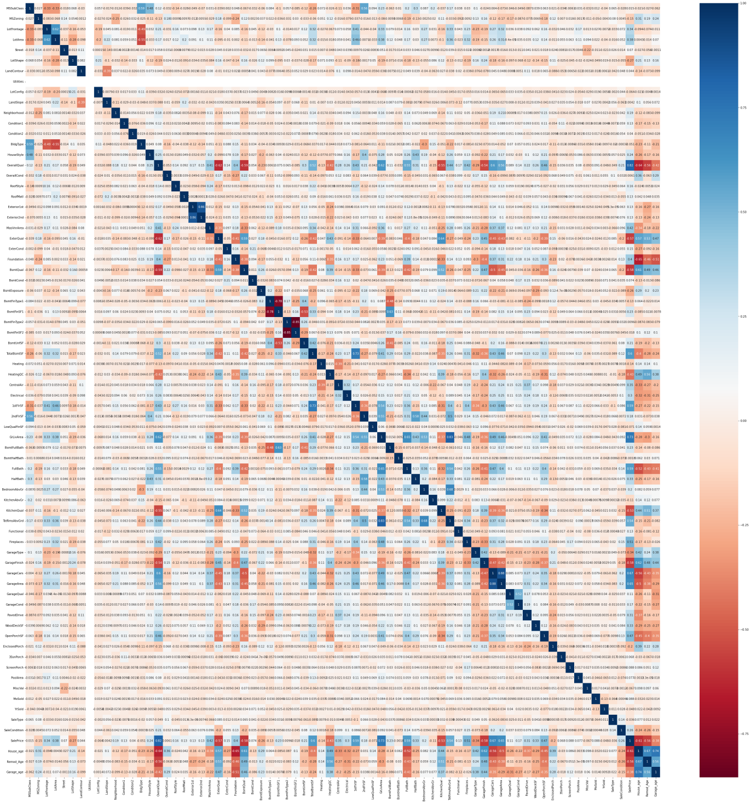

* Max Number of features are positively correlated with SalePrice
* Yearbuild is negatively correlated with EnclosedPorch
* BsmtUnfsF is negatively correlated with BsmtFullBath
* ExternalQual,BsmtQual,KitchenQual, GarageFinish is negatively correlated with saleprice

**Dropping Utilities feature as it is not showing scope on sale price**

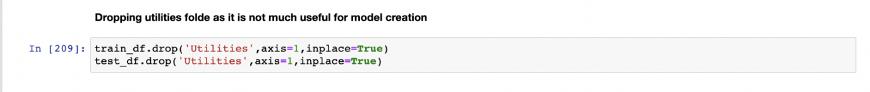

**Feature Selection**

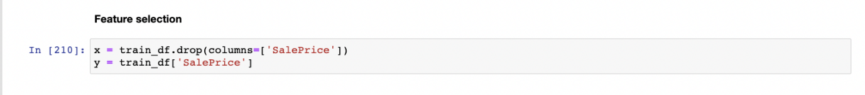

**Standardization**

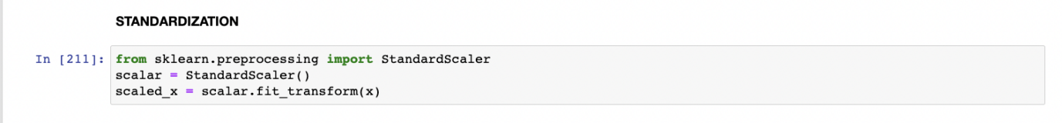

#### **Checking for multicollinearity using variation inflation factor**

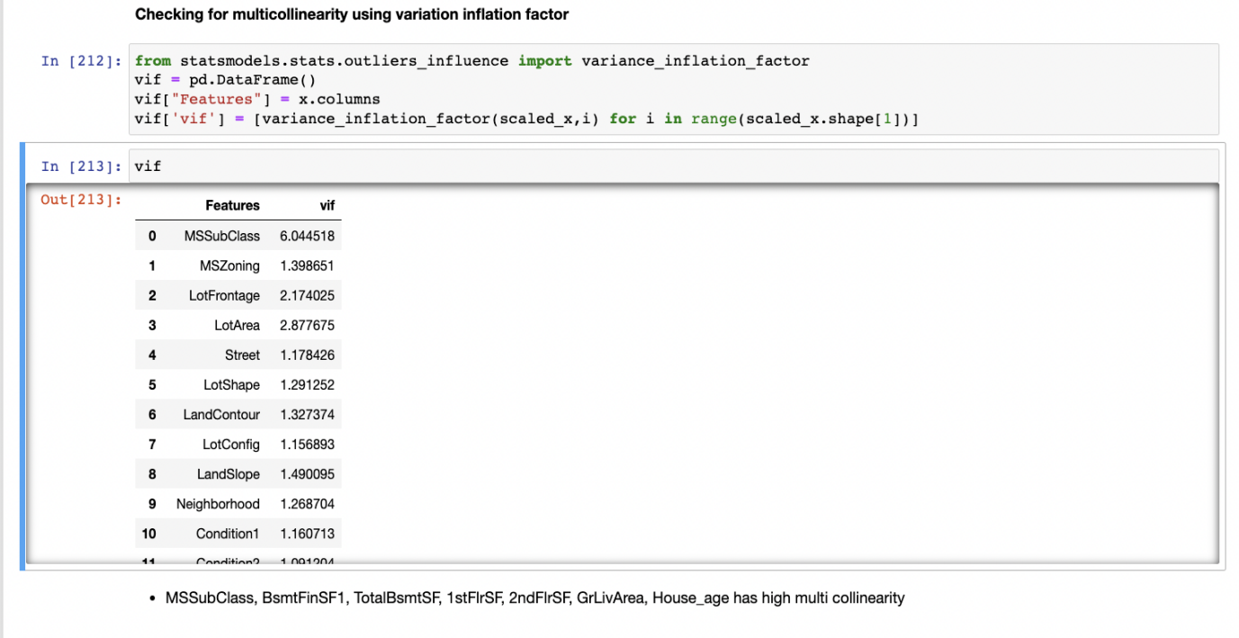

MSSubClass, BsmtFinSF1, TotalBsmtSF, 1stFlrSF, 2ndFlrSF, GrLivArea, House_age has high multi collinearity.

#### **Principle Component Analysis**

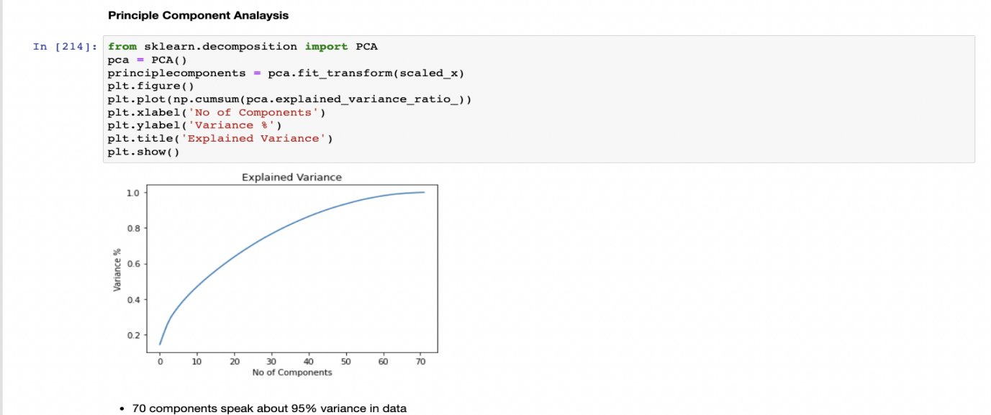

70 components speak about 95% variance in data.

**Selecting K-best Features and dropping un-useful columns**

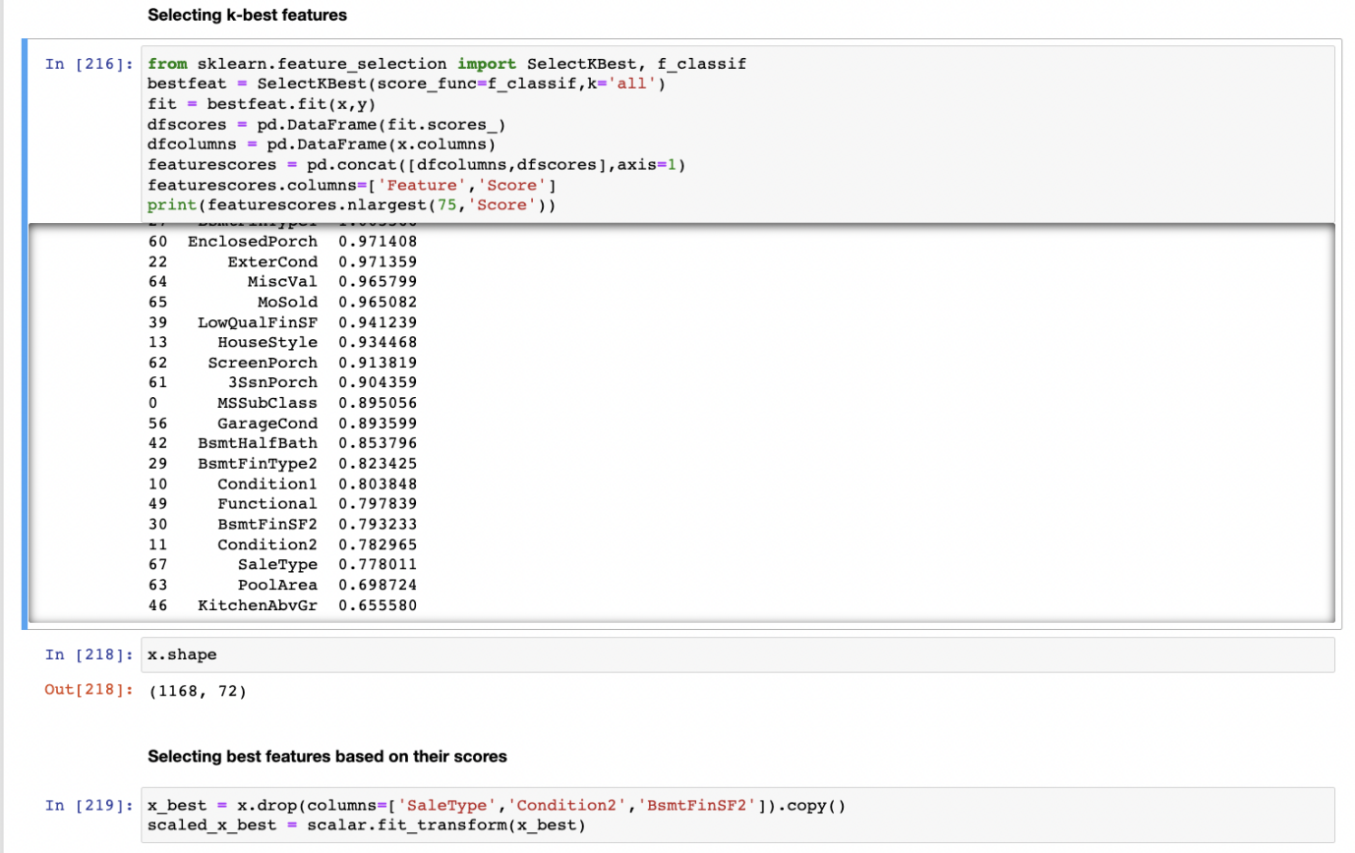

**Importing Model Libraries and Finding Random state**

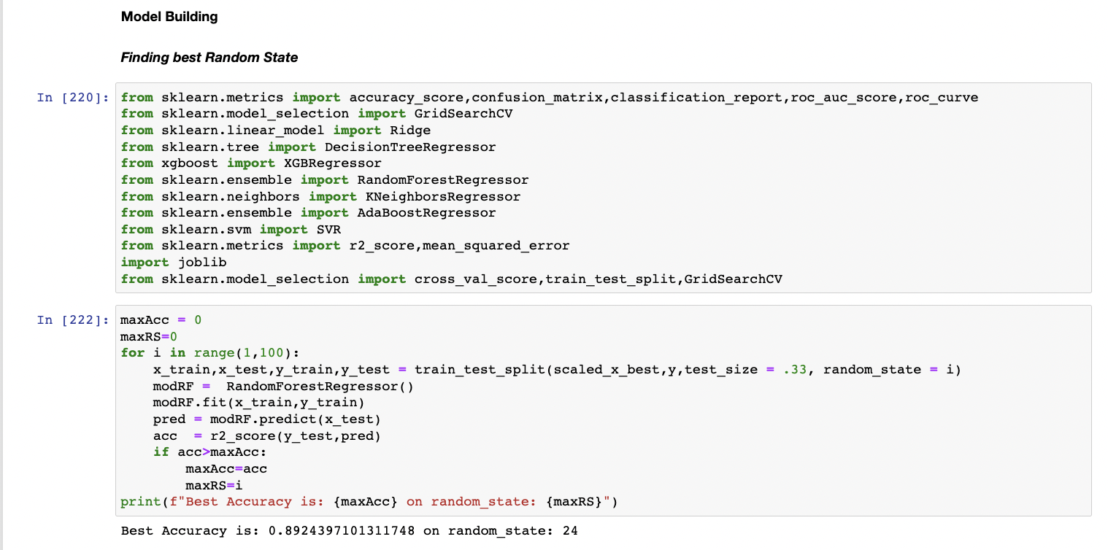

Best Accuracy is: 0.8924397101311748 on random_state: 24

**Training Data with Different Model Libraries**

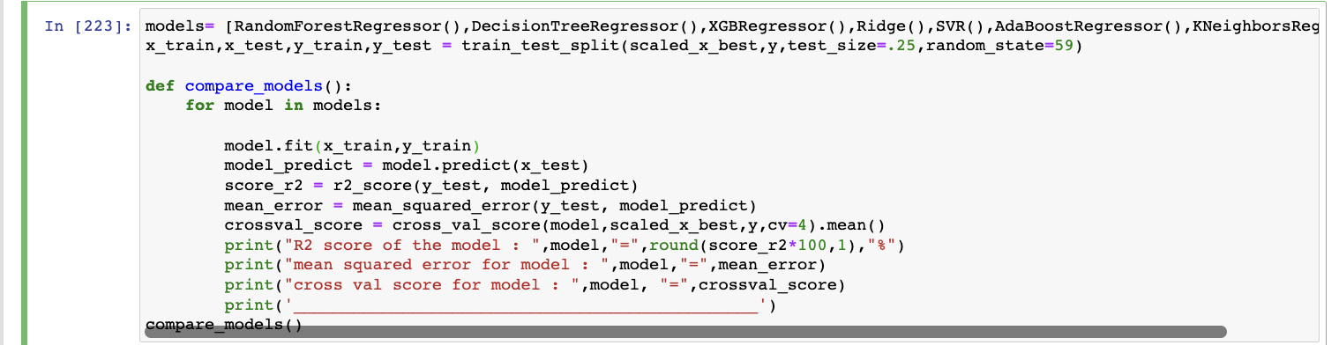

**Results for Model Training**

R2 score of the model : RandomForestRegressor() = 87.1 %

mean squared error for model : RandomForestRegressor() = 0.12404986872351596

cross val score for model : RandomForestRegressor() = 0.8543177964627404

_______________________________________________

R2 score of the model : DecisionTreeRegressor() = 71.2 %

mean squared error for model : DecisionTreeRegressor() = 0.27647808913929195

cross val score for model : DecisionTreeRegressor() = 0.7029503817522236

_______________________________________________

R2 score of the model : XGBRegressor(base_score=0.5, booster='gbtree', callbacks=None,

colsample_bylevel=1, colsample_bynode=1, colsample_bytree=1,

early_stopping_rounds=None, enable_categorical=False,

eval_metric=None, gamma=0, gpu_id=-1, grow_policy='depthwise',

importance_type=None, interaction_constraints='',

learning_rate=0.300000012, max_bin=256, max_cat_to_onehot=4,

max_delta_step=0, max_depth=6, max_leaves=0, min_child_weight=1,

missing=nan, monotone_constraints='()', n_estimators=100, n_jobs=0,

num_parallel_tree=1, predictor='auto', random_state=0, reg_alpha=0,

reg_lambda=1, ...) = 87.5 %

mean squared error for model : XGBRegressor(base_score=0.5, booster='gbtree', callbacks=None,

colsample_bylevel=1, colsample_bynode=1, colsample_bytree=1,

early_stopping_rounds=None, enable_categorical=False,

eval_metric=None, gamma=0, gpu_id=-1, grow_policy='depthwise',

importance_type=None, interaction_constraints='',

learning_rate=0.300000012, max_bin=256, max_cat_to_onehot=4,

max_delta_step=0, max_depth=6, max_leaves=0, min_child_weight=1,

missing=nan, monotone_constraints='()', n_estimators=100, n_jobs=0,

num_parallel_tree=1, predictor='auto', random_state=0, reg_alpha=0,

reg_lambda=1, ...) = 0.12040357496536425

cross val score for model : XGBRegressor(base_score=0.5, booster='gbtree', callbacks=None,

colsample_bylevel=1, colsample_bynode=1, colsample_bytree=1,

early_stopping_rounds=None, enable_categorical=False,

eval_metric=None, gamma=0, gpu_id=-1, grow_policy='depthwise',

importance_type=None, interaction_constraints='',

learning_rate=0.300000012, max_bin=256, max_cat_to_onehot=4,

max_delta_step=0, max_depth=6, max_leaves=0, min_child_weight=1,

missing=nan, monotone_constraints='()', n_estimators=100, n_jobs=0,

num_parallel_tree=1, predictor='auto', random_state=0, reg_alpha=0,

reg_lambda=1, ...) = 0.8526377678389339

_______________________________________________

R2 score of the model : Ridge() = 82.3 %

mean squared error for model : Ridge() = 0.16960554508358183

cross val score for model : Ridge() = 0.8549982920253969

_______________________________________________

R2 score of the model : SVR() = 82.1 %

mean squared error for model : SVR() = 0.17225632516358153

cross val score for model : SVR() = 0.8024883218752944

_______________________________________________

R2 score of the model : AdaBoostRegressor() = 80.4 %

mean squared error for model : AdaBoostRegressor() = 0.1881442455910854

cross val score for model : AdaBoostRegressor() = 0.7988978681272337

_______________________________________________

R2 score of the model : KNeighborsRegressor() = 78.3 %

mean squared error for model : KNeighborsRegressor() = 0.20842969143319431

cross val score for model : KNeighborsRegressor() = 0.7651416544528145

_______________________________________________

**Random Forest Regression is giving good accuracy results comparing with other models**

**Performing HyperParameter Tuning for Random Forest Regression**

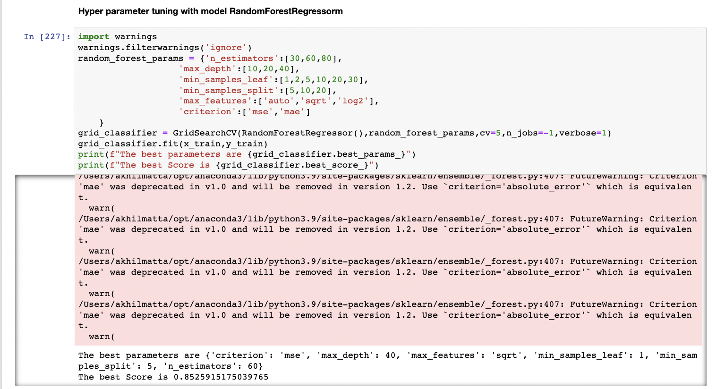

The best parameters are {

'criterion': 'mse',

'max_depth': 40,

'max_features': 'sqrt',

'min_samples_leaf': 1,

'min_samples_split': 5,

'n_estimators': 60}

**The best Score is 0.8525915175039765**

**Training the model with good Parameters**

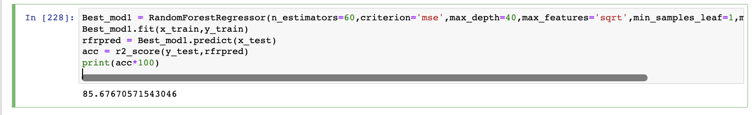

The Random Forest Regressor model got accuracy of

85.6%

**Saving the Model**

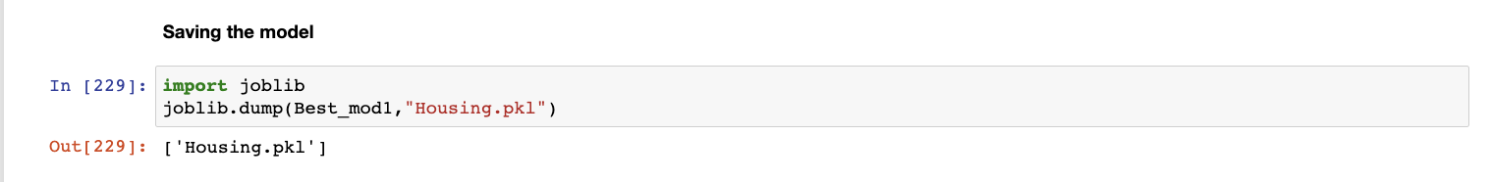

**Loading the model**

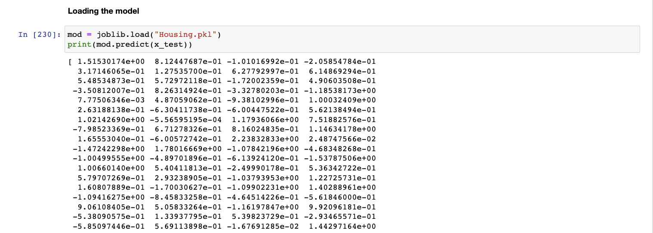

**Visualising Predicted and actual values**

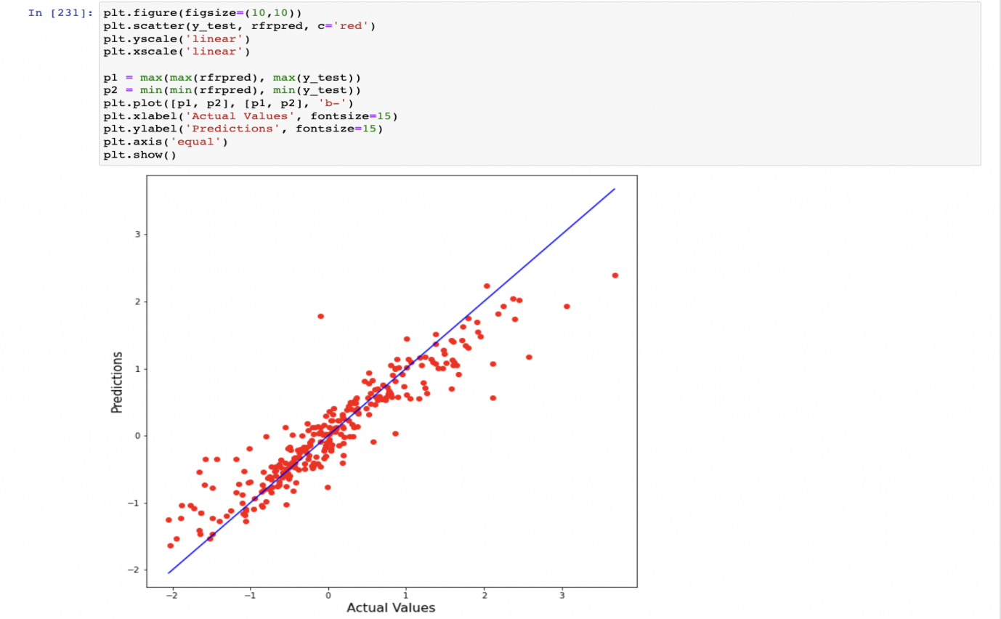

**Testing Model with Test Data**

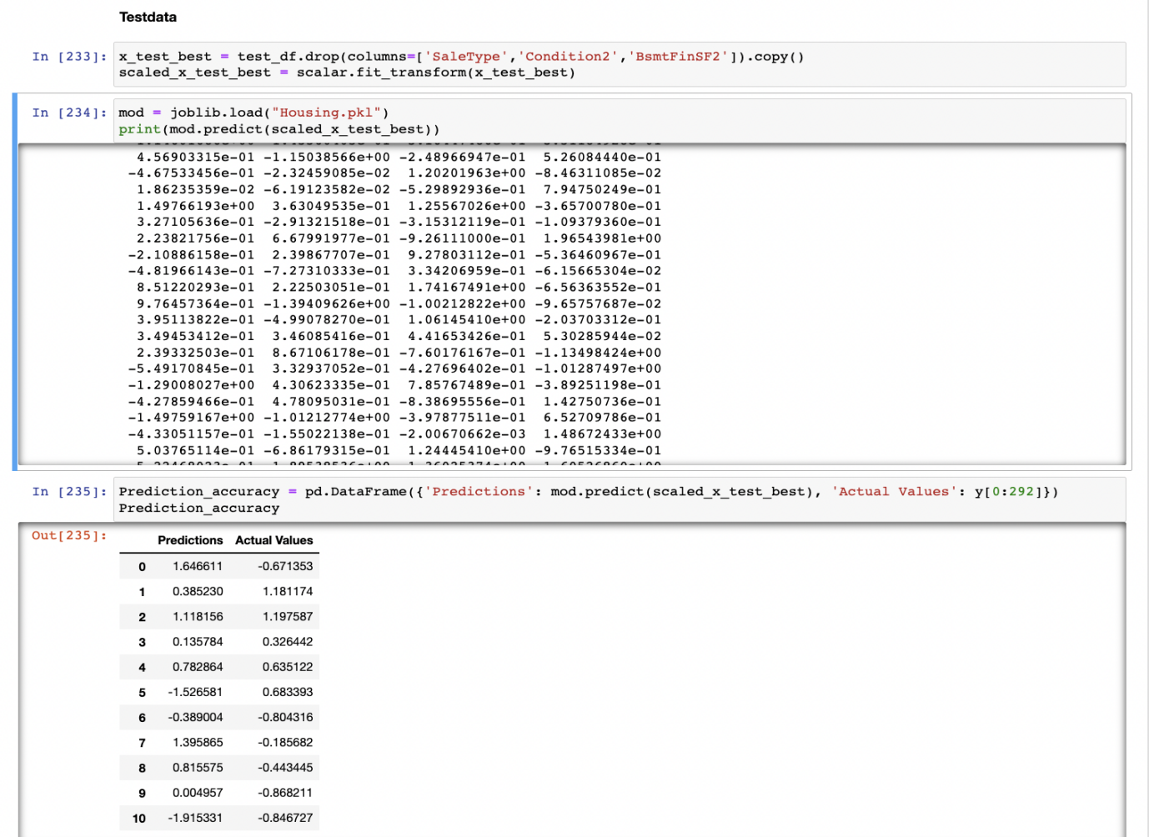

Random Forest Regressor Performed the best out of all the models

that were tested.

**CONCLUSION**

**Key Findings and Conclusions of the Study and Learning**

**Outcomes with respect to Data Science**

Based on the in-depth analysis of the Housing Project, The

Exploratory analysis of the datasets, and the analysis of the Outputs

of the models the following observations are made:

• Structural attributes of the house Structural attributes of the

house like lot size, lot shape, quality and condition of the house,

garage capacity, rooms, Lot frontage, number of bedrooms,

bathrooms, overall finishing of the house etc play a big role in

influencing the house price.

• Neighbourhood qualities can be included in deciding house

price.

• Various plots like Barplots,Countplots and Lineplots helped in

visualising the Feature-label relationships which corroborated

the importance of structural and locational attributes for

estimating Sale Prices.

• Due to the Training dataset being very small, the outliers had to

be retained for proper training of the models.

• Therefore, Random Forest Regressor, being robust to outliers

and being indifferent to non linear features, performed well

despite having to work on small dataset.

**Limitations of this work and Scope for Future Work**

While features that focus on structural and locational attributes of

housing properties are crucial for estimating the Sale Price of

Housing properties, they aren’t the only factors that influence the

value in the housing market. Data on

Demographics(Age,Income,Regional preferences of buyers, purpose

of buying a property) is very important for understanding the

Housing market. Interest Rates too impact the price and demand of

houses. Economic cycles also influence Real Estate prices.

Government Policies, Regulations, Legalizations are also important factors that may influence the sales of houses. The availability of

data on above features would help build a predictive model that

would more accurately understand the relationship between the

features and target variable and yield more accurate predictions.

**Thank You**